A Report on

DEEPINSPECT AI
AI DRIVEN NETWORK SECURITY SYSTEM

Submitted for partial fulfilment of award of

BACHELOR OF TECHNOLOGY

Degree

In

Computer Science & Engineering

By

ANKIT RAJ ( CSE – 2100300100029 )
ARYAN GUPTA ( CSE – 2100300100046 )
SHASHANK KUMAR SRIVASTAVA
( CSE-DS – 2100301540070 )

In Supervision of

MR. AJAY KUMAR
(COMPUTER SCIENCE & ENGINEERING)



INDERPRASTHA ENGINEERING COLLEGE, GHAZIABAD,

Dr. A P J ABDUL KALAM TECHNICAL UNIVERSITY
LUCKNOW
May 2025

Declaration

We hereby declare that this submission is my own work and that, to the best of our knowledge and belief, it contains no material previously published or written by another person nor material which to a substantial extent has been accepted for the award of any other degree or diploma of the university or other institute of higher learning, except where due acknowledgment has been made in the text.

Date : 12-05-2025

Signature :

Certificate

Certified that Aryan Gupta, Ankit Raj, Shashank Kumar Srivastava has carried out the project work presented in this report entitled “DEEPINSPECT AI” for the award of Bachelor of Technology from Inderprastha Engineering College, Ghaziabad, under my supervision. The report embodies result of original work and studies carried out by Student himself and the contents of the report do not form the basis for the award of any other degree to the candidate or to anybody else.

SUPERVISOR : MR. AJAY KUMAR (COMPUTER SCIENCE & ENGINEERING)

Date: 12-05-2025

Acknowledgement

We take this opportunity to thank our teachers and friends who helped us throughout the project.

First and foremost, I would like to thank our guide for the project (Mr. Ajay Kumar, CSE Department) for his valuable advice and time during development of project.

We would also like to thank Dr. Vijai Singh (HOD, Computer Science Department) for his constant support during the development of the project.

Name : Aryan Gupta
Roll No. : 2100300100046
Signature :

Name : Ankit Raj
Roll No. : 2100300100029
Signature :

Name : Shashank Kumar Srivastava
Roll No. : 2100301540070
Signature :

Abstract

In the rapidly evolving landscape of cybersecurity, traditional rule-based intrusion detection and prevention systems are increasingly inadequate in identifying and responding to the sophisticated and dynamic threats posed by modern cyber attackers. Static systems, while useful for known threat signatures, often struggle with detecting novel or subtle malicious behaviours that evolve over time. This research introduces the design, implementation, and evaluation of an AI-Driven Network Security System (AIDNSS) that harnesses the capabilities of machine learning and data-driven modelling to proactively secure digital network environments. The proposed system combines real-time traffic monitoring with advanced anomaly detection techniques to uncover suspicious behaviour that may indicate the presence of cyber threats such as Distributed Denial of Service (DDoS) attacks, port scanning activities, malware communications, and data exfiltration attempts. Leveraging both supervised and unsupervised learning algorithms, including decision trees, support vector machines, and clustering models like K-means and DBSCAN, the system continuously learns from network data to improve its detection accuracy over time. This adaptive approach reduces the reliance on manually defined rules and signature databases, enabling the system to evolve alongside emerging threat patterns without constant human oversight. Furthermore, the system incorporates intelligent automation to not only detect potential intrusions but also initiate timely response actions—such as alert generation, traffic blocking, or policy updates—thereby minimizing the window of vulnerability. The research includes the deployment and testing of the system in a controlled, simulated network environment to evaluate its performance against standard attack scenarios. Metrics such as detection rate, false positive rate, response time, and resource utilization were analysed to benchmark the system against conventional security solutions. Experimental results show a significant improvement in threat detection capabilities, including a marked reduction in false positives and enhanced responsiveness, affirming the potential of AI-powered approaches in next-generation network security architectures. Ultimately, this work seeks to bridge the gap between the static nature of legacy security mechanisms and the fluid, increasingly intelligent landscape of cyber threats, emphasizing the role of machine learning as a cornerstone for future cybersecurity solutions.

TABLE OF CONTENTS

CHAPTER 1
INTRODUCTION

In today’s hyperconnected digital world, cyber threats are evolving faster than ever, becoming increasingly sophisticated, stealthy, and destructive. From ransomware and phishing attacks to insider threats and zero-day vulnerabilities, traditional network security solutions—primarily signature-based or rule-driven—struggle to keep up with the dynamic and unpredictable nature of cybercrime. This calls for an intelligent, adaptive, and autonomous solution that not only responds to threats in real time but anticipates and mitigates them before damage is done. DeepInspect AI addresses this critical need by introducing an advanced, AI-powered network security system built to revolutionize the way networks are protected.

DeepInspect AI is a cutting-edge AI-Driven Network Security System designed to detect, analyse, and neutralize cyber threats using a combination of machine learning, deep learning, behavioural analytics, and real-time threat intelligence. By integrating artificial intelligence into the core of network defence, the system moves beyond reactive measures and enters the realm of proactive, self-learning, and context-aware cybersecurity.

At the heart of DeepInspect AI lies a powerful multi-layered threat detection engine, capable of scanning enormous volumes of network traffic to identify anomalies, unauthorized access attempts, policy violations, and other signs of malicious activity. Leveraging both supervised learning (for classifying known threats) and unsupervised learning (for detecting unknown or novel threats), the system continuously adapts to the changing threat landscape. For instance, AI models are trained on labelled datasets of cyberattacks to recognize common malware signatures, while clustering algorithms and anomaly detection methods allow the system to spot irregular behaviours not previously encountered.

One of DeepInspect AI’s core strengths is its use of behavioural analysis and context-aware detection. Instead of relying solely on static indicators, the system builds dynamic behavioural profiles of users, endpoints, and applications. If a device suddenly starts communicating with an unusual domain or a user attempt to access sensitive data during odd hours, DeepInspect AI flags the activity for inspection. This contextual understanding significantly reduces false positives while ensuring early detection of subtle and complex threats such as Advanced Persistent Threats (APTs) and insider attacks.

The system also employs real-time packet inspection and traffic flow analysis, enabling it to examine both metadata and payload content of packets traversing the network. Combined with threat intelligence feeds and historical data, DeepInspect AI correlates patterns across time and nodes to detect coordinated attacks, lateral movement within the network, and exfiltration attempts. To maximize responsiveness, DeepInspect AI includes an autonomous response mechanism. Once a threat is identified, the system can trigger predefined actions like quarantining affected devices, revoking access credentials, throttling suspicious traffic, or alerting network administrators. Additionally, a reinforcement learning framework helps fine-tune these responses over time by learning from incident outcomes—improving both accuracy and effectiveness with each event.

From a research perspective, DeepInspect AI explores and implements advanced AI paradigms such as federated learning (to train models collaboratively without compromising data privacy), graph neural networks (for detecting relational anomalies in network traffic), and natural language processing (to analyse social engineering or phishing attempts). These capabilities future-proof the system and ensure adaptability to emerging threats and attack vectors.

In an era where digital transformation drives nearly every aspect of human life, the significance of robust network security has never been more critical. The exponential growth of internet-connected devices, cloud-based infrastructures, and digital services has expanded the attack surface for cybercriminals. Traditional network security measures, while foundational, are increasingly proving inadequate in keeping up with the sophistication, scale, and frequency of modern cyber threats. This pressing concern has led to a paradigm shift in how we approach cybersecurity—ushering in the integration of Artificial Intelligence (AI) as a cornerstone for advanced, adaptive, and intelligent network defence mechanisms.

At its core, the system integrates multiple layers of AI capabilities. Supervised learning algorithms are employed to classify known threats and flag suspicious behaviours based on labelled datasets, while unsupervised learning is used to uncover unknown attack vectors and anomalous patterns without relying on pre-existing classifications. Additionally, reinforcement learning techniques contribute to the decision-making process by optimizing response strategies based on feedback and outcomes from previous actions. These AI models are continually refined and retrained using real-world data to improve their accuracy and adaptability.

One of the key features of the system is real-time threat monitoring through packet inspection, traffic analysis, and endpoint behaviour tracking. By analysing incoming and outgoing data packets, the system can detect irregularities such as unusual data transfer rates, unauthorized access attempts, or deviations from established traffic baselines. When potential threats are identified, the AI engine can autonomously trigger predefined security protocols such as isolating affected nodes, blocking suspicious IP addresses, or alerting network administrators for further investigation.

Another essential aspect of the project is its focus on explainability and transparency. Given the critical nature of network security, the system incorporates features that allow security professionals to interpret AI-driven decisions, investigate flagged incidents, and audit system performance. This fosters trust and enables human oversight, which is crucial in high-stakes environments where false positives or overlooked threats can have significant consequences.

From a research and development standpoint, this project explores the convergence of AI and cybersecurity, delving into areas such as neural networks for malware detection, natural language processing (NLP) for analysing phishing attempts, and federated learning for decentralized security intelligence. By pushing the boundaries of conventional security frameworks, the AI-Driven Network Security System exemplifies a forward-thinking approach to digital safety—an approach that is adaptive, intelligent, and ever-evolving.

In essence, DeepInspect AI represents a transformative leap in cybersecurity—a system that not only guards the network perimeter but understands and protects the dynamic fabric of the entire digital ecosystem. By combining real-time monitoring, intelligent threat detection,

  - Problem Definition

With the digital transformation of industries and the rise of cloud computing, Internet of Things (IoT), and remote work environments, modern networks have become highly dynamic and complex. While this evolution has brought immense benefits in terms of connectivity and productivity, it has also introduced significant vulnerabilities and expanded the potential attack surface for malicious actors. Cyberattacks have grown not only in number but also in sophistication, often bypassing traditional security mechanisms through techniques such as polymorphic malware, advanced persistent threats (APTs), social engineering, and zero-day exploits.

Conventional network security solutions, such as firewalls, intrusion detection systems (IDS), and antivirus software, predominantly rely on static rules, predefined signatures, and manual intervention. These methods are inherently reactive and incapable of adapting to new, previously unseen attack vectors. They lack the contextual intelligence required to analyse patterns of behaviour, understand evolving threats, or provide real-time adaptive defence. As a result, organizations frequently face delayed threat detection, high false-positive rates, and inadequate incident response times—all of which can lead to data breaches, financial losses, and reputational damage.

Furthermore, the volume of data generated by modern networks is overwhelming for human security teams to analyse and interpret manually. Security Operation Centres (SOCs) are often flooded with alerts, many of which are redundant or low priority, causing alert fatigue and increasing the risk of missing critical threats. The absence of intelligent automation in these systems also leads to inefficient use of human resources and delayed mitigation of real attacks.

Therefore, the core problem addressed by this project is the inability of traditional network security systems to effectively detect and respond to sophisticated, fast-evolving cyber threats in real time. There is a clear and pressing need for an intelligent, self-learning, and adaptive system that can automatically monitor network traffic, detect anomalies, identify threats, and initiate appropriate responses with minimal human intervention.

The DeepInspect AI – AI-Driven Network Security System is proposed as a solution to bridge this gap. By incorporating advanced artificial intelligence and machine learning techniques, the system aims to provide:

    - Real-time, autonomous threat detection and response
    - Behavioural and anomaly-based threat analysis
    - Reduced false positives and improved alert prioritization
    - Scalability across various network environments
    - Integration with existing security infrastructures

This project tackles the fundamental challenges of traditional cybersecurity by redefining network security as an intelligent, proactive, and continuously evolving process—ensuring not just defence, but resilience in the face of modern cyber threats.

  - Background

With the rapid advancement of transformative technologies such as Artificial Intelligence (AI), cloud computing, and the Internet of Things (IoT), modern network infrastructures have grown in scale, complexity, and interconnectivity. While these innovations have introduced significant benefits in terms of efficiency, scalability, and performance, they have simultaneously expanded the attack surface for cyber threats. Traditional rule-based security mechanisms struggle to cope with the dynamic and sophisticated nature of modern cyberattacks—many of which are now AI-driven, adaptive, and capable of bypassing conventional defences.

DeepInspect AI was conceived in response to these evolving challenges in the cybersecurity landscape. The idea stems from the realization that AI—when integrated into network security systems—can dramatically improve threat detection by learning from patterns, behaviours, and anomalies in data traffic. By drawing inspiration from successful AI applications in domains like fraud detection, spam filtering, and image recognition, the project seeks to transition from reactive to proactive security measures.

The core objective of DeepInspect AI is to develop a comprehensive security solution that uses machine learning (ML) and deep learning (DL) algorithms to continuously monitor and analyse network traffic in real-time. Instead of relying solely on known attack signatures, the system learns to detect subtle deviations from normal network behaviour, enabling it to identify previously unseen threats, including zero-day attacks.

Key capabilities of the proposed system include:

1.2.1 Predictive Threat Detection: Identifying potential attacks based on behavioural anomalies before they cause damage.
1.2.2 Autonomous Response Mechanisms: Automatically initiating countermeasures such as traffic filtering, alerting, or device isolation upon detecting high-risk anomalies.
1.2.3 Intelligent Alerting: Reducing alert fatigue for security teams by minimizing false positives and prioritizing actionable threats.
1.2.4 Adaptive Learning: Continuously evolving with the threat landscape through feedback loops and model retraining.

In essence, DeepInspect AI aims to augment the capabilities of human security analysts rather than replace them. By handling routine analysis and flagging high-risk events with high confidence, the system allows security personnel to focus on strategic decision-making and incident resolution. This fusion of AI and cybersecurity sets a foundation for creating more resilient and autonomous digital infrastructures in an increasingly interconnected world.

  - Objectives of the Proposed System

The DeepInspect AI system is designed with a set of well-defined objectives aimed at enhancing the effectiveness, adaptability, and trustworthiness of modern network security frameworks through AI. These objectives are detailed below:

1.3.1 Real-Time Traffic Analysis and Anomaly Detection
To design and develop an AI-powered system capable of continuously analysing real-time network traffic and detecting abnormal patterns that may indicate malicious activity or potential cyberattacks.

1.3.2 Machine Learning-Based Threat Classification
To implement machine learning models trained on historical and synthetic datasets to classify various types of threats, including identifying previously unseen (zero-day) attacks using behaviour-based detection.
1.3.3 Automated Response and Incident Handling
To enable real-time monitoring and intelligent response mechanisms such as:
- Immediate alert generation upon anomaly detection
- Isolation of compromised devices from the network
- Revocation or modification of access privileges

1.3.4 Reduction of False Positives
To minimize the false positive rate through:
- Behavioral profiling of network entities
- Context-aware analysis of traffic
- Adaptive learning mechanisms that evolve over time

1.3.5 Scalable and Modular Architecture
To build a scalable and modular security framework that:
- Supports deployment across networks of varying sizes
- Integrates seamlessly with existing security tools and infrastructures
- Allows future extensions with minimal reconfiguration

1.3.6 Explainability and Auditability
To ensure trust in AI-driven decisions by:
- Providing explainable outputs that clarify why an alert was generated
- Maintaining detailed logs for audit trails and regulatory compliance

  - Feasibility Study, Need, and Significance

This section evaluates the practical viability, necessity, and importance of the DeepInspect AI project in the context of current cybersecurity challenges.

    - Feasibility Study

      - Technical Feasibility:
The project builds upon well-established and accessible technologies. It utilizes:

- AI frameworks such as TensorFlow, PyTorch, and Scikit-learn for model development.
- Real-time packet analysers like Wireshark and tcpdump to capture and inspect network traffic.
- Networking and data stream tools for traffic routing and preprocessing.
- Cloud platforms such as AWS, Azure, or Google Cloud for scalable and distributed deployment using containers and microservices.
These tools provide a robust technical foundation for implementing the proposed system efficiently.

1.4.1.2 Operational Feasibility:
DeepInspect AI is designed to integrate seamlessly into existing network environments. Key considerations include:

- Non-intrusive deployment, running in parallel with current infrastructure without requiring major changes.
- User-friendly interfaces like dashboards and alert panels for network administrators.
- Minimal training requirements, thanks to intuitive design and automation, enabling quick adoption by security teams.

1.4.1.3 Economic Feasibility:
The system ensures cost-effectiveness through:

- Use of open-source libraries and frameworks, reducing licensing costs.
- Containerization and cloud-native deployment, optimizing resource usage and operational expenses.
- Preventive cost savings, as timely detection and response can prevent costly data breaches, system downtimes, and reputational damage over time.

    - Need for the System

With rising incidents of cyberattacks, traditional rule-based and signature-based security mechanisms are no longer sufficient. Threats are now more:

- Traditional security systems often fail to detect sophisticated threats like encrypted, obfuscated, or polymorphic malware, and require frequent manual rule updates.

- The exponential growth in cyber threats and increasing use of AI by attackers demands equally intelligent and adaptive defence mechanisms.

- Harder to detect, especially zero-day attacks and internal breaches.
DeepInspect AI addresses this growing need by incorporating intelligent behaviour analysis, continuous learning, and real-time responsiveness—capabilities that legacy systems lack.

- There is a clear need for real-time, autonomous, and intelligent monitoring solutions that can predict and respond to emerging threats effectively.

    - Significance of the System

The significance of DeepInspect AI lies in its potential to:

- Revolutionize network security by shifting from reactive to proactive defence strategies.
- Empower cybersecurity professionals by automating routine detection and enhancing threat visibility.
- Build trust through explainable AI, helping organizations meet compliance and audit requirements.
- Support scalability and future-readiness, making it suitable for enterprise networks, IoT ecosystems, and cloud-native architectures.

In essence, DeepInspect AI fills a critical gap in the cybersecurity domain by offering an intelligent, adaptable, and cost-effective solution to modern threats.

  - Novelty of the Project

DeepInspect AI introduces several groundbreaking features that distinguish it from conventional cybersecurity systems. The innovative aspects of the project are outlined below:

    - Behaviour-Based Threat Detection

Unlike traditional systems that rely heavily on static signatures or predefined rules, DeepInspect AI focuses on behavioural analysis. It identifies threats by detecting deviations from normal user or device behaviour, enabling it to uncover stealthy and evolving attack patterns.
    - Multi-Modal Learning Integration

The system combines supervised, unsupervised, and reinforcement learning approaches:

- Supervised learning helps classify known threats from labelled data.
- Unsupervised learning detects hidden patterns and unknown anomalies in unlabelled traffic.
- Reinforcement learning allows the system to learn from feedback, improving its response strategies over time.

    - Context-Aware Anomaly Detection

DeepInspect AI constructs dynamic behavioural baselines for users, devices, and applications. This context-awareness enables the system to:

- Distinguish between normal and suspicious actions even if they are similar in structure.
- Reduce false positives by considering environmental context, time, and usage patterns.

    - Real-Time Adaptability

The system is designed to adapt to evolving threat landscapes in real time, enabling:

- Zero-day threat detection
- Identification of novel attack vectors that bypass traditional detection methods

    - Explainable AI (XAI) Components

DeepInspect AI incorporates explainable AI mechanisms that:

- Offer human-readable justifications for each detection or response action
- Support trust, accountability, and compliance, especially in regulated industries

    - Federated Learning Potential

The architecture allows for future integration of federated learning, enabling:

- Decentralized model training across multiple nodes or organizations
- Privacy-preserving learning, as raw data remains local while only model updates are shared

  - Technical Specifications

    - Hardware and Software Requirements

TABLE –
Hardware Requirements:
Component | Minimum Specification
Processor | Intel i5 or higher / 2.4 GHz+ Quad-Core
RAM | 8 GB (16 GB Recommended)
Storage | 256 GB SSD or higher
Network Adapter | Gigabit Ethernet / Wireless Adapter
GPU | (Optional) NVIDIA GPU for training deep learning models

TABLE –
Software Requirements:
Category | Tools / Libraries
Operating System | Linux (Ubuntu 20.04+), Windows 10+, or macOS
Programming Language | Python 3.8+
AI/ML Libraries | TensorFlow, PyTorch, Scikit-learn, Keras
Data Processing | Pandas, NumPy, Matplotlib, Seaborn
Network Monitoring | Wireshark, tcpdump, Scapy
Visualization & Dashboards | Flask/Django, React.js or Streamlit (for UI), Grafana (optional)
Database | MySQL / PostgreSQL / MongoDB
IDE / Code Editor | VS Code, Jupyter Notebooks
Containerization (optional) | Docker, Kubernetes for deployment
Cloud (optional) | AWS EC2/S3, Azure, or GCP for scalability

CHAPTER 2
LITERATURE REVIEW

The application of Artificial Intelligence (AI) and Machine Learning (ML) in cybersecurity has gained significant traction in recent years due to the limitations of traditional rule-based Intrusion Detection Systems (IDS). These conventional systems are often ineffective against sophisticated and evolving threats. One of the earliest contributions to anomaly-based intrusion detection was made by Denning [1], who proposed a model for identifying unauthorized system access by monitoring deviations from normal behaviour. This foundational work paved the way for intelligent, behaviour-based security systems. Dhanabal and Shantharajah [2] conducted a comparative analysis of machine learning algorithms using the KDD Cup 1999 dataset, demonstrating that algorithms such as Random Forest and Decision Trees could effectively classify known attacks. However, their study also emphasized the inability of these models to detect zero-day threats. Similar concerns were raised by Sommer and Paxson [6], who discussed the limits of ML in practical intrusion detection, particularly its susceptibility to adversarial manipulation and overfitting. Buczak and Guven [3] provided a comprehensive survey of ML techniques in network security, categorizing methods into supervised, unsupervised, and semi-supervised learning. They highlighted the effectiveness of SVM, k-Means, and ensemble methods in various security applications. Additionally, Nguyen and Armitage [7] explored the role of traffic classification in anomaly detection, reinforcing the importance of preprocessing and feature selection.

Recent studies have shifted focus toward deep learning. Sahu and Yadav [4] applied Recurrent Neural Networks (RNNs) and Convolutional Neural Networks (CNNs) to model complex sequential attack patterns in network traffic. While the models showed improved detection accuracy, they required extensive computational resources and large training datasets. Similarly, Kim et al. [8] employed deep autoencoders to detect novel threats with high precision, though their performance decreased in high-speed network environments.

Vinayakumar et al. [9] presented a scalable deep learning framework for real-time intrusion detection using Long Short-Term Memory (LSTM) networks, capable of capturing temporal dependencies in traffic data. In another effort, Shone et al. [10] developed a non-symmetric deep autoencoder for unsupervised anomaly detection, showing promising results on benchmark datasets.

The CICIDS2017 dataset, introduced by the Canadian Institute for Cybersecurity, has emerged as a benchmark for modern IDS research. Sharafaldin et al. [5] demonstrated the dataset's utility in developing hybrid systems capable of detecting both known and unknown threats. Likewise, Ferrag et al. [11] reviewed CICIDS2017 applications and highlighted its richness in capturing contemporary attack vectors.

Despite these advancements, many systems still struggle with high false-positive rates and real-time performance limitations. Lin et al. [12] examined the trade-offs between detection accuracy and speed in IDS systems, concluding that lightweight models like decision trees, when combined with anomaly detection, can improve responsiveness. Shen et al. [13] integrated federated learning to enable collaborative threat detection without compromising data privacy, an emerging challenge in distributed systems.

This research proposes a hybrid AI-based solution that addresses these challenges using both supervised and unsupervised learning models to enhance adaptability and detection capability. Hybrid frameworks like those proposed by Alrawashdeh and Purdy [14] and Tang et al. [15] have already shown that combining techniques such as deep learning and clustering significantly boosts the ability to detect zero-day attacks while maintaining operational efficiency.

2.1 Existing System – Theoretical and Methodological Contributions

The integration of Artificial Intelligence (AI) into network security has seen significant advancements in recent years, as traditional security measures become increasingly ineffective against evolving cyber threats. Researchers and practitioners have explored various AI-based approaches to address key cybersecurity challenges, including threat detection, anomaly detection, malware classification, and intrusion prevention. Below, we review the theoretical and methodological contributions from various scholarly papers, articles, and books that form the foundation for the development of an AI-driven network security system.

2.1.1. AI and Machine Learning in Network Security

AI's application in network security is based on the premise that intelligent systems can automatically recognize patterns, detect anomalies, and predict potential security breaches without human intervention. Machine learning (ML), particularly supervised and unsupervised learning algorithms, plays a critical role in threat detection systems. Liu et al. (2018) in their work on anomaly detection emphasized the significance of using unsupervised learning algorithms, such as k-means clustering and autoencoders, to identify unknown and evolving attack patterns.

Supervised Learning for Attack Classification

Supervised learning has been widely used in classification tasks where known attack patterns are labeled and used to train models. Chandola et al. (2009) discussed various supervised learning techniques in anomaly detection, including decision trees, support vector machines (SVM), and neural networks. These techniques rely on pre-labeled datasets of network traffic to identify known threats like DoS (Denial of Service), DDoS, and SQL injection attacks. The challenge here lies in ensuring the availability of a sufficiently large, high-quality labeled dataset, which can be difficult to obtain for newer or zero-day attacks.

Unsupervised Learning for Unknown Threats

On the other hand, unsupervised learning algorithms help detect previously unknown attacks by analyzing network traffic for unusual behavior without prior labels. Sahin et al. (2020) proposed the use of unsupervised methods like clustering and autoencoders to identify anomalous activities in real-time network traffic. These systems analyze data patterns and alert security teams to suspicious behavior, providing early detection of emerging threats. This approach is especially important for zero-day exploits that are not yet documented in security databases.

2.1.2. Deep Learning and Neural Networks for Advanced Threat Detection

Deep learning (DL), particularly deep neural networks (DNNs), has been applied to network security to further improve detection accuracy, handling large and complex datasets that traditional machine learning models might struggle with. Zhao et al. (2018) demonstrated how Convolutional Neural Networks (CNNs) can be used to classify network traffic into normal and malicious classes. Kim et al. (2019) also explored the use of Long Short-Term Memory (LSTM) networks for identifying long-term dependencies in network data, making it suitable for detecting APTs, which often involve sophisticated, multi-stage attacks.

Hybrid Approaches: Combining AI and Traditional Security Models

Hybrid models that combine AI with traditional intrusion detection techniques have also shown promise. Alenezi et al. (2021) reviewed the integration of AI techniques with signature-based systems. Their work emphasized how combining deep learning with traditional signature-based approaches enhances threat detection accuracy and reduces the rate of false positives. This hybrid methodology allows systems to leverage the strengths of both AI-driven learning (adaptability) and traditional methods (precision).

2.1.3. Autonomous Response Systems

AI-driven security systems are not only concerned with detection but also with the automated response to security events. Autonomous response mechanisms, driven by AI models, can trigger predefined actions such as blocking suspicious IP addresses, isolating compromised devices, or updating firewall rules. Bhuyan et al. (2018) explored the use of reinforcement learning for real-time decision-making in response to network security incidents. They proposed that an AI model, through interaction with the environment, can optimize its responses to security breaches, providing the system with the ability to learn from past actions and improve over time.

Reinforcement Learning for Adaptive Défense

Reinforcement learning (RL) offers a promising approach to autonomous response systems. By using rewards and penalties based on the success or failure of security measures, RL algorithms can adaptively determine the best course of action in dynamic and complex network environments. Xie et al. (2020) showed that RL models could autonomously adjust firewall settings and block suspicious traffic without human intervention, thereby enhancing real-time threat mitigation.

2.1.4. Explainable AI (XAI) in Network Security

While AI-driven network security systems offer powerful capabilities, they often face challenges in terms of transparency and trust, especially when human oversight is necessary for critical decision-making. Explainable AI (XAI) is a growing field focused on making AI models more interpretable and understandable to human users. Ribeiro et al. (2016) introduced the concept of Local Interpretable Model-Agnostic Explanations (LIME), which allows users to understand the decisions made by machine learning models by generating locally interpretable approximations. In cybersecurity, XAI is vital for security professionals to interpret AI-driven alerts and ensure that the system is acting appropriately, reducing the reliance on black-box decision-making.

Interpretability in AI for Security Decision-Making

Gunning (2017) highlighted that in security-critical applications like network defence, it's essential to balance performance with interpretability, as security professionals need to trust the AI system’s decisions. Models such as decision trees or rule-based approaches are sometimes used alongside deep learning models to provide transparent reasoning for each decision made by the system.

2.1.5. Real-Time Threat Detection and Scalability

Scalability is another key challenge for AI-driven network security systems. As organizations grow, so too does the complexity of their networks, making it essential for security systems to handle large volumes of data while maintaining real-time performance. Kaspersky et al. (2019) discussed the challenges of scaling AI-driven cybersecurity solutions to enterprise networks, which require continuous updates and high throughput. They suggested that distributed computing and cloud-based architectures could help scale security solutions without compromising performance.

Edge Computing for Real-Time Threat Detection
Emerging techniques such as edge computing, where data is processed closer to the source, have also been explored for real-time detection. Sundararajan et al. (2020) demonstrated how edge-based AI systems could improve the detection and mitigation of cyber threats at the network’s edge, minimizing latency and ensuring faster response times.

CHAPTER 3
PROPOSED SYSTEM

The DeepInspect AI – AI-Driven Network Security System aims to revolutionize network security by leveraging advanced machine learning, deep learning, and anomaly detection techniques to autonomously monitor, detect, and respond to cybersecurity threats in real-time. The system is designed to overcome the limitations of traditional security systems, providing a proactive and intelligent approach to safeguarding digital infrastructures against evolving and sophisticated threats.

3.1. System Overview

The proposed system integrates Artificial Intelligence (AI) and Machine Learning (ML) models to perform dynamic analysis of network traffic, detect anomalies, and classify potential threats. Unlike conventional methods, which rely on predefined signatures or static rules, the system adapts to changing threat landscapes, ensuring continuous protection without requiring constant updates.
The system works on three primary fronts:

    - Real-Time Threat Detection: Identifying anomalies and attacks in real-time through machine learning-based behavioural analysis.
    - Autonomous Response: Automatically responding to detected threats through predefined actions such as isolation of compromised devices, blocking malicious IP addresses, or adjusting firewall rules.
    - Explainable AI (XAI): Ensuring transparency and trust in AI decisions by offering human-readable explanations for each security action taken.

3.2. Key Features

3.2.1. Real-Time Anomaly Detection

- The system continuously monitors network traffic, analyzing patterns of behavior and flagging any anomalies that deviate from established baselines.
- Unsupervised Learning techniques (e.g., clustering algorithms and autoencoders) are employed to identify previously unknown attacks that do not match known signatures, such as zero-day vulnerabilities.
- Supervised Learning models (e.g., decision trees, SVMs) are used to identify common threats based on historical labeled data.
- Deep Learning models (e.g., Convolutional Neural Networks (CNN), Long Short-Term Memory (LSTM) networks) are employed to enhance the detection of complex, multi-stage attacks like advanced persistent threats (APTs).

3.2.2. Autonomous Threat Mitigation

- The system automatically responds to detected threats by executing predefined actions based on the severity and nature of the anomaly detected.
- Reinforcement Learning (RL) is employed to optimize response strategies, where the system learns and adapts its actions over time for improved effectiveness.
- Potential mitigation actions include:
  - Blocking or isolating malicious IP addresses or devices.
  - Triggering alerts for human intervention when necessary.
  - Adjusting firewall configurations or updating intrusion detection rules.

3.2.3. Explainable AI (XAI)

- Transparency in decision-making is crucial in security-critical systems. The DeepInspect AI system incorporates explainable AI techniques, such as LIME (Local Interpretable Model-Agnostic Explanations) and SHAP (SHapley Additive exPlanations), to provide interpretable insights into why a specific action was taken.
- This ensures that security analysts can understand the rationale behind automated decisions, increasing trust and enabling better decision-making in case of false positives or complex situations.

3.2.4. Scalability and Integration

- The system is designed to be highly scalable, capable of handling large-scale enterprise networks with multiple devices and traffic flows.
- Cloud-based architecture allows for distributed processing, enabling efficient management and scaling of resources as per the needs of the organization.
- The system can be integrated with existing security infrastructure, such as traditional firewalls, intrusion detection systems (IDS), and security information and event management (SIEM) platforms, enhancing its overall effectiveness.

3.2.5. Continuous Learning and Adaptation

- As the system interacts with network traffic and detects new types of threats, it continuously updates its models through a feedback loop.
- Federated Learning allows the system to learn from distributed devices without sharing sensitive data, enhancing security while preserving privacy.
- This continuous learning process ensures that the system stays up to date with new attack vectors, even in highly dynamic network environments.

3.3. System Architecture

The system architecture for DeepInspect AI is designed to be modular and flexible, enabling integration with existing network infrastructures. The architecture consists of the following key components:

    - Data Collection Layer:

  - This layer consists of network traffic monitoring tools, such as Wireshark, tcpdump, or custom packet sniffers, which collect raw data from the network.
  - Data is captured in real-time, including packet-level information such as IP addresses, ports, protocols, and payload data.
    - Preprocessing Layer:

  - Data collected from the network is pre-processed and transformed into a format suitable for analysis.
  - This involves cleaning, filtering, and normalizing the data to remove irrelevant information or noise that may hinder accurate analysis.

3.3.3. AI/ML Analysis Layer:

  - This layer is responsible for performing data analysis using AI/ML models.
  - The Supervised Learning models are trained using historical attack data to classify known threats, while Unsupervised Learning models detect anomalies or new attack patterns.
  - Deep Learning models are used for more complex detection tasks, such as identifying multi-stage or highly sophisticated attacks.
  - The Reinforcement Learning module is responsible for improving the system's response actions over time, based on feedback from the environment.

    - Threat Detection and Response Layer:

  - When a potential threat is detected, the system initiates an appropriate response, which can range from blocking the attack to alerting the security team.
  - This layer is tightly integrated with firewall and intrusion prevention systems (IPS) to execute real-time countermeasures.

3.3.5. Explainability Layer:

  - This layer provides transparency for every decision made by the system, offering detailed explanations for threat detection and response.
  - Security analysts can review the rationale behind each decision, enhancing trust and enabling intervention when necessary.

3.3.6. Monitoring and Dashboard Layer:

  - The system includes a user-friendly dashboard for real-time monitoring and alerting.
  - The dashboard provides visualizations of detected threats, system status, and ongoing incidents, allowing security analysts to monitor the health of the network and respond effectively.

  - Proposed Workflow

3.4.1. Traffic Collection: Network traffic is continuously collected using monitoring tools.

3.4.2. Data Preprocessing: The data is cleaned, normalized, and transformed for analysis.

3.4.3. Anomaly Detection: The system applies AI/ML models to identify potential threats in real-time.

3.4.4. Threat Classification: Detected threats are classified into predefined categories (e.g., DDoS, malware, insider attack).

3.4.5. Autonomous Response: The system triggers a predefined response based on the severity and nature of the detected threat.

3.4.6. Explainability: The system provides an interpretable explanation for the decision made (e.g., detected anomaly, response triggered).

3.4.7. Learning and Adaptation: The system continues to learn from new network data and feedback to improve future performance.

3.5. Expected Benefits of the Proposed System

3.5.1. Proactive defence: Unlike traditional systems, which are reactive, and update based on known threats, DeepInspect AI detects and mitigates attacks in real-time, even for previously unknown threats.

    - Reduced Human Intervention: By automating threat detection and response, the system reduces the workload on security teams, allowing them to focus on high-priority tasks.
    - Enhanced Accuracy: The combination of AI/ML models and deep learning improves threat detection accuracy and reduces false positives.

    - Scalability: The system can easily scale to accommodate growing networks, making it suitable for both small businesses and large enterprises.

    - Continuous Improvement: The system's ability to learn from new data ensures it adapts to emerging threats over time.

CHAPTER 4
SOFTWARE DEVELOPMENT ANALYSIS

The Software Requirement Analysis phase outlines both the functional and non-functional aspects of the proposed system, including detailed use case scenarios, system behaviour, and modular decomposition. This section provides a foundational understanding of what the software system is expected to do and how it should perform.

4.1. Functional Requirements

Functional requirements define the key features and functionalities that the DeepInspect AI system must deliver to fulfil its intended purpose.

a) Use Case Diagram

The use case diagram below illustrates the interaction between external actors (users) and the internal processes of the system. The primary actors include the Network Administrator, Security Analyst, and System Itself (AI Engine).

FIGURE –
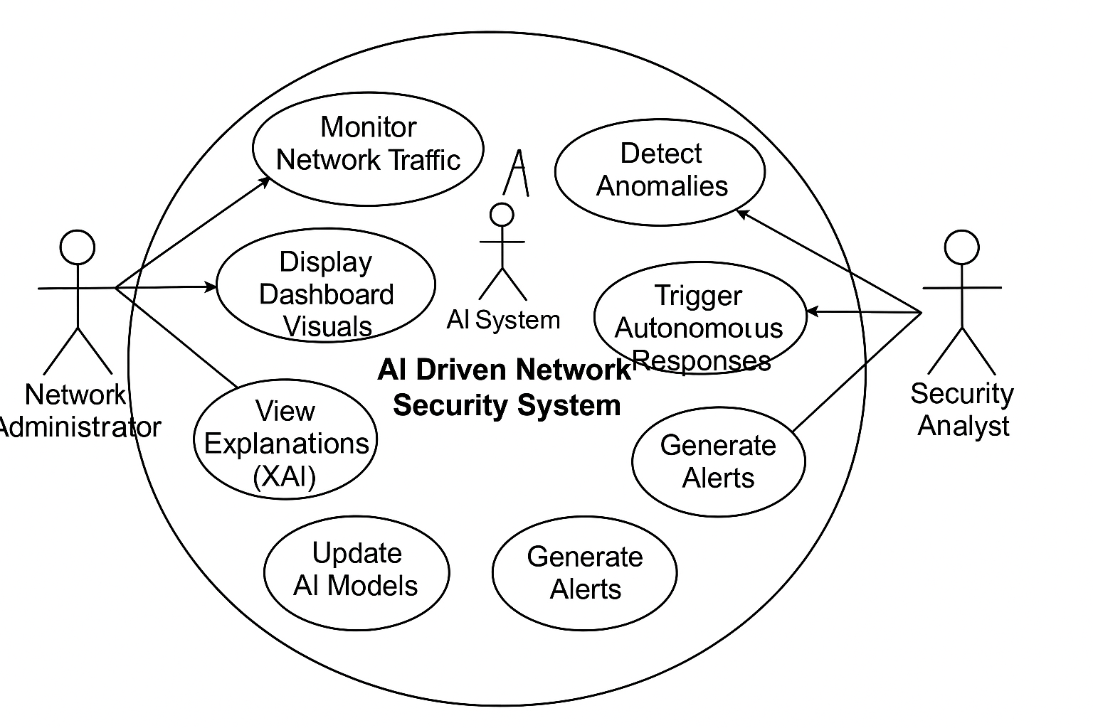

b) Use Case Descriptions

TABLE –

Use Case | Description
Monitor Network Traffic | Continuously collect and log data packets from the network using integrated sniffers or external monitoring tools.
Detect Anomalies | Analyse the captured data using AI/ML to detect patterns that deviate from normal behaviour.
Classify Threats | Based on the anomaly detection results, classify threats as DDoS, malware, intrusion, etc.
Trigger Autonomous Response | Execute actions such as isolating IPs, adjusting firewall rules, or sending alerts based on threat severity.
Generate Alerts | Send real-time alerts to the security analyst via dashboard, email, or other configured channels.
View Dashboard Visuals | Allow users to see live updates on network health, incident history, threat categories, and system actions.
View Explanations (XAI) | Present interpretable reports on why the system classified or responded to a threat, using XAI tools like SHAP or LIME.
Update AI Models | Enable system retraining and learning from feedback or new data (may be manual or scheduled depending on configuration).

4.2. Nonfunctional Requirements

Nonfunctional requirements define the quality attributes and constraints of the system.

TABLE –

Category | Description
Performance | The system must detect threats and trigger a response within 2 seconds of detection for real-time protection.
Scalability | The system should scale horizontally to support thousands of devices and concurrent traffic flows in large enterprise networks.
Reliability | Must operate 24/7 with a minimum uptime of 99.9%. Failover and recovery mechanisms should be in place.
Security | All sensitive data must be encrypted in transit and at rest. The system should have role-based access control (RBAC).
Usability | The dashboard must be intuitive, provide visual alerts, and require minimal training for network administrators.
Maintainability | The codebase should be modular and documented to allow easy updates and bug fixes.
Portability | The system should run across multiple platforms (Linux, Windows, Cloud-based deployments).
Compliance | Should comply with security regulations such as GDPR, HIPAA (if applicable), or NIST depending on the organizational context.

4.3. Major Modules and Their Functionalities

Below is a list of the main modules in the system along with their respective functionalities:

TABLE –

Module | Functionality
Network Traffic Collector | Captures raw packets and metadata (IP, ports, protocols, timestamps) from network interfaces in real time.
Preprocessing Module | Cleans, filters, and transforms raw packet data into structured datasets suitable for ML model input.
Anomaly Detection Engine | Uses unsupervised ML/DL algorithms (e.g., Isolation Forest, Autoencoders) to detect behavior anomalies in network traffic.
Threat Classification Unit | Applies supervised learning models to categorize the type of threat detected (e.g., brute force, malware, insider threat.
Response Engine | Triggers system-defined responses such as blocking IPs, disabling ports, or sending alerts based on threat level.
Explainability Module (XAI) | Generates human-readable explanations for model decisions using SHAP, LIME, or decision trees.
Dashboard and Reporting UI | Displays real-time network stats, historical analysis, detected threats, responses, and allows user interaction and configuration.
Model Updater and Feedback Loop | Allows manual or automated updates to AI models based on new data, false positives, or analyst feedback for continuous learning.
Security & Access Control | Manages authentication, encryption, user roles, and permissions to ensure secure usage and administration.

CHAPTER 5
SYSTEM ANALYSIS & DESIGN

5.1 Class Designs

Class Design refers to the creation of a blueprint for the system’s classes that describe the attributes (properties) and methods (functions) that objects of the class can perform. In object-oriented design, classes serve as the foundation for the system’s components. For the DeepInspect AI project, we might design classes for different functionalities such as network traffic analysis, threat detection, and response generation.

Example Classes for DeepInspect AI:

- User Class

  - Attributes: UserID, Username, Password, Role, Email, Contact
  - Methods: createAccount(), authenticate(), updateProfile(), resetPassword()

- NetworkTraffic Class

  - Attributes: TrafficID, Timestamp, SourceIP, DestinationIP, Protocol, PacketSize, Status
  - Methods: captureTraffic(), filterTraffic(), analyzeTraffic()

- Threat Class

  - Attributes: ThreatID, TrafficID, Type, Severity, Description, DetectedTime
  - Methods: identifyThreat(), classifyThreat(), logThreat()

- Response Class
  - Attributes: ResponseID, ThreatID, ActionTaken, ResponseTime, AdminID
  - Methods: generateResponse(), executeResponse(), updateResponse()

- AI_Model_Log Class

  - Attributes: LogID, Version, TrainingDate, Accuracy, ModelType, Notes
  - Methods: trainModel(), logModelInfo(), updateModel()

FIGURE –

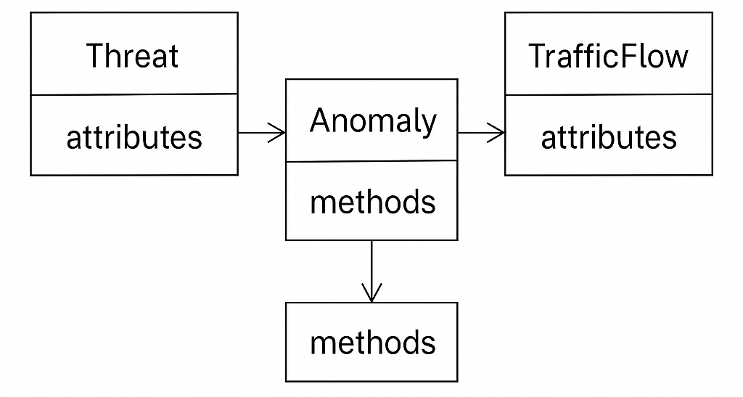

5.2 Sequence Diagrams

Sequence Diagrams illustrate how objects in a system interact with each other over time. The sequence of events is shown in a vertical timeline, and it helps identify how processes flow and which components are involved at each step.
For DeepInspect AI, a typical sequence diagram might depict the following processes:

5.2.1. Threat Detection:

  - Step 1: A NetworkTraffic object captures a network packet.
  - Step 2: The packet is passed to the ThreatDetection class for analysis.
  - Step 3: If an anomaly is detected, a Threat object is created.
  - Step 4: The Threat object triggers an alert to the User or Admin.
  - Step 5: The response system is activated by the Response class, which takes actions like isolating devices or revoking access.

5.2.2. AI Model Training:

  - Step 1: The AI_Model_Log object receives data to train the model.
  - Step 2: The system trains using the data and updates the model version.
  - Step 3: After training, the accuracy and performance metrics are stored in the AI_Model_Log object.

5.3 Activity Diagrams

Activity Diagrams describe the flow of control between activities (or tasks) within the system. They show the order in which actions are executed and how decisions lead to various paths of execution.
Activity diagrams are a key component of system modelling that illustrate the dynamic aspects of the system. They depict workflow behaviour, control flow, and the sequential or parallel execution of operations within the system. For a complex system like DeepInspect AI, which involves multiple decision-making layers, automated responses, and iterative machine learning cycles, activity diagrams help visualize processes clearly for developers, stakeholders, and cybersecurity analysts.

FIGURE -

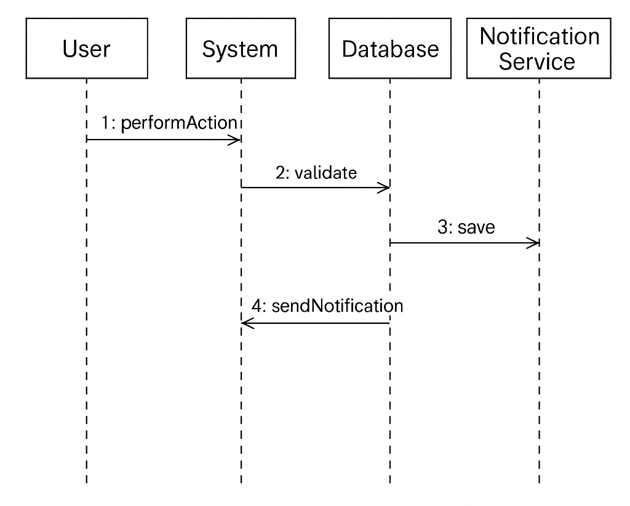

For DeepInspect AI, an activity diagram might represent:

    - Threat Detection Process:

Detailed Flow of Activities:

- Start → System initiates traffic monitoring using packet sniffing tools or API integrations with firewalls.

- Action 1: Capture Network Packets

  - The system collects raw packets from network interfaces using tools like tcpdump, Wireshark, or via an integrated sensor module.

- Action 2: Extract Features from Packets

  - Features such as IP headers, protocol types, port numbers, payload entropy, and time intervals are extracted and prepared as input for the ML model.

- Decision 1: Is the Packet Suspicious?

  - A lightweight classifier performs an initial anomaly detection.
    - If No:
      - The packet is classified as benign.
      - → Log minimal metadata (e.g., timestamp, IP pair).
      - → Return to packet capture loop.
    - If Yes:
      - The packet is flagged for deep inspection.

- Action 3: Perform Deep Inspection & Threat Classification

  - A more sophisticated ML/DL model (e.g., Random Forest, CNN) is applied to assess the threat class: malware, DoS, phishing, lateral movement, etc.

- Action 4: Log and Store Detected Threat

  - The threat is logged into the system database along with:
    - Type
    - Source IP
    - Confidence score
    - Suggested severity
    - Associated user/session ID
    - Time detected

- Decision 2: Is an Immediate Response Required?

  - Based on a response policy matrix:
    - Threat severity, asset value, previous occurrences, and confidence level are used to assess urgency.
    - If No:
      - Alert is logged and queued for analyst review via dashboard.
    - If Yes:
      - The response module is triggered.

- Action 5: Execute Automated Response
  - Actions may include:
    - Isolating the host/device from the network.
    - Blocking source IP via firewall rules.
    - Triggering a notification to security admins.
    - Creating a case/ticket in the incident response queue.

- End: System returns to the monitoring loop for continued inspection.

    - Model Training &Deployment Process:

Detailed Flow of Activities:

- Start → Triggered either manually (via admin console) or automatically based on model drift detection or data update thresholds.

- Action 1: Collect and Aggregate Training Data

  - Sources:
    - Historical logs
    - Public datasets (CICIDS, NSL-KDD, UNSW-NB15)
    - Synthetic traffic generated from testbeds or honeypots
    - Threat intelligence feeds

- Action 2: Clean and Preprocess Data

  - Tasks include:
    - Handling missing values
    - Normalizing numerical features
    - One-hot encoding categorical attributes
    - Filtering out noise/outliers
    - Partitioning data into training/validation/test sets

- Action 3: Feature Selection and Engineering

  - Use feature selection techniques (e.g., mutual information, PCA)
  - Engineer new features like:
    - Rate of connection requests
    - Sequence patterns
    - Protocol frequency distribution
- Action 4: Model Training

  - Models like Random Forest, XGBoost, or deep neural networks are trained using defined training sets.
  - Cross-validation is performed to avoid overfitting.

- Decision 1: Does the Model Meet Performance Criteria?

  - Metrics evaluated:
    - Accuracy
    - Precision/Recall
    - F1-Score
    - AUC-ROC
    - False positive rate
  - Thresholds are pre-defined based on production needs.
    - If Yes:
      - The model is ready for deployment.
    - If No:
      - The following actions are triggered:
        - Adjust hyperparameters (grid search/random search)
        - Evaluate alternative algorithms
        - Augment data (e.g., SMOTE, generate synthetic threats)
        - Re-train

- Action 5: Deploy Model to Detection Engine

  - Push trained model to the active environment.
  - Older versions are archived for rollback.
  - Deployment is logged with metadata (model ID, training data source, hash, etc.)

- Action 6: Monitor Model in Production

  - Post-deployment monitoring includes:
    - Prediction distribution shifts
    - Accuracy trends
    - Real-world false positive/negative rates

- End: System enters passive monitoring until the next retraining trigger occurs.
FIGURE –
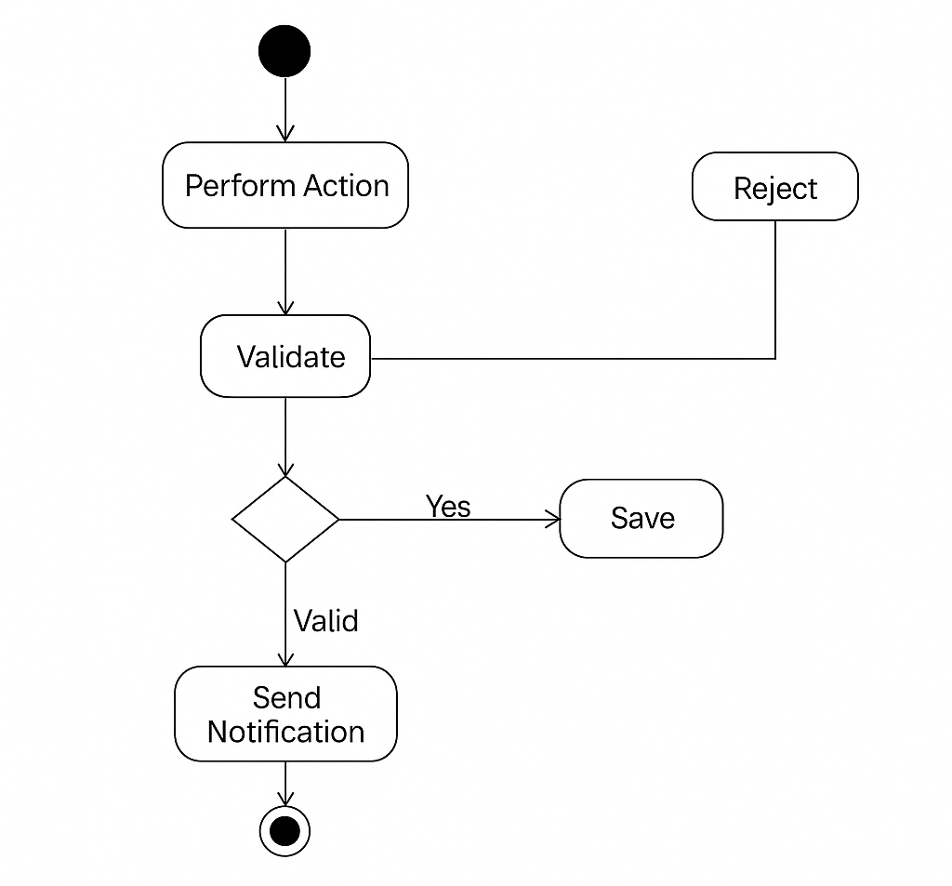
5.4 Data Flow Diagram(DFDs) of the project

Data Flow Diagrams (DFDs) are a critical component of system analysis and design. They provide a visual representation of how data flows through a system, highlighting the inputs, processing steps, storage points, and outputs. DFDs focus on what happens to data as it moves through the system, rather than how or in what sequence these events occur.

In the context of DeepInspect AI, DFDs are instrumental in modelling the flow of network data, threat intelligence, response actions, and human interaction across various system components. The diagrams are structured across hierarchical levels, starting from a broad overview (Level 0) and gradually breaking down into more detailed views (Level 1 and beyond).

FIGURE –
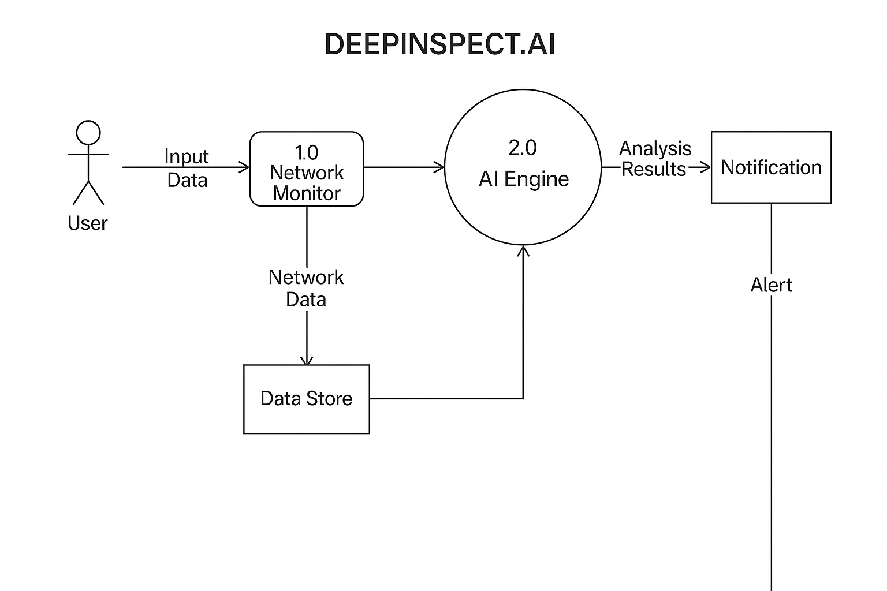

For DeepInspect AI, a possible DFD might represent:

    - Level 0 DFD (Context Level):

The Level 0 DFD, also known as the context diagram, provides a high-level, bird’s-eye view of the entire system. It treats DeepInspect AI as a single process and shows its interaction with external entities, major data stores, and data exchanges.
Entities, Processes, and Flows

      - External Entities:

  - Users: Includes security analysts, IT managers, and administrators who monitor the system and respond to alerts.
  - Admins: Responsible for configuring system policies, initiating model retraining, and managing stored data.
  - Network Devices: Routers, switches, endpoints, firewalls from which data packets are captured.
  - Cloud Infrastructure: Cloud-based environments where traffic monitoring or storage might occur.

      - Central Process:

  - DeepInspect AI Core System: Encompasses all internal processing, including traffic capture, AI-based threat detection, response handling, and user communication.

      - Data Stores:

  - Threat Database: Stores known threats, detected attacks, and classifications.
  - Response Logs: Maintains a historical record of responses taken, both manual and automated.
  - AI Models Repository: Stores trained machine learning models and associated metadata.

      - Data Flows:

  - Network Packets: Incoming real-time traffic from connected devices.
  - Threat Alerts: Outgoing notifications or reports to users/admins.
  - User Feedback: Labels, confirmations, or overrides of detection results, useful for retraining models.
  - Response Commands: Automated isolation instructions or firewall rules sent back to devices.

Narrative Explanation

In the Level 0 DFD, DeepInspect AI receives real-time traffic from external network devices and processes this traffic to detect malicious activity. If threats are detected, threat alerts are generated and forwarded to users/admins, while relevant metadata is stored in the threat database. Based on severity, the system may initiate automated responses (e.g., isolate device) which are logged in the response logs. Additionally, users/admins provide feedback, which influences future decision-making and supports AI model training.

    - Level 1 DFD (Decomposition of Processes):

The Level 1 DFD decomposes the central system into a set of interconnected subprocesses, each representing a core function within DeepInspect AI. This level allows us to observe the internal data flow, the interaction between subcomponents, and the transformation of data as it moves from input to output.

5.4.2.1. Processes:

- Process 1: Network Traffic Analysis

  - Captures raw packet streams from devices using sniffers.
  - Performs preprocessing (feature extraction, filtering, normalization).
  - Stores processed traffic data in the Network Traffic Logs.

- Process 2: Threat Detection

  - Applies trained ML models to processed network data.
  - Detects and classifies threats (e.g., DoS, botnets, malware).
  - Stores detection results in the Threat Logs.
  - Sends alerts to users or triggers policy-defined responses.

- Process 3: Response Generation

  - Evaluates severity, asset sensitivity, and past history.
  - Determines whether an automated response is justified.
  - Sends response commands to affected devices.
  - Records actions taken in the Response Logs.

- Process 4: Feedback Integration & Model Update

  - Collects feedback from users on alert accuracy.
  - Analyses model performance over time.
  - Updates model performance metrics or triggers retraining.
  - Communicates with the AI Models Repository.

5.4.2.2. Data Stores:

- Network Traffic Logs: Persistently store captured and processed network packet data.
- Threat Logs: Archive records of all detected threats including timestamps, severity, and classification.
- Response Logs: Document response actions initiated by the system.
- AI Models Repository: Houses the AI/ML models, performance logs, and training data versions.

5.4.2.3. Data Flows:

- Incoming Traffic: Packet streams flow into the system via Process 1.
- Processed Features: Feature vectors generated and passed to Process 2.
- Threat Alerts: Sent from Process 2 to end-users or Process 3.
- Response Commands: Resulting commands (e.g., quarantine host, block IP) sent from Process 3 to devices.
- User Feedback: Flows from users back to Process 4 for labelling or corrections.
- Model Updates: Refined models pushed from Process 4 into the live environment.

Narrative Explanation

At this level of detail, we see how data transforms as it passes through the system’s internal modules. For example, raw packets are not simply used as-is but are pre-processed and feature-engineered before being passed to detection models. Detected threats do not directly result in action; rather, the system checks for policy compliance and potential impact before issuing any command. Feedback loops are vital — user interactions help the AI learn and adapt, ensuring the detection system remains current and effective.

The Level 1 DFD also underscores the separation of concerns — each process has a defined responsibility, supporting scalability and maintainability.

Optional Future: Level 2 DFD (Further Breakdown)

If needed, Level 2 DFDs could be introduced to break down individual subprocesses even further. For instance:

- Process 2: Threat Detection could be decomposed into:

  - 2.1 Load Model
  - 2.2 Apply Classifier
  - 2.3 Compute Confidence
  - 2.4 Determine Threat Type
This is useful in highly complex systems or for development teams aiming to create microservices or parallel processing pipelines.

Data Flow Diagrams provide a structured and logical view of how DeepInspect AI processes information, highlighting the essential interactions and dependencies between data sources, processes, and outputs. They are particularly valuable during:

- System design and architecture reviews
- Security and compliance audits
- Training of new developers or analysts
- Model maintenance and optimization planning

By combining Levels 0 and 1, we gain both a macro and micro perspective of the system, ensuring clarity, traceability, and operational transparency.

5.5 Database Design

Database design involves defining the structure of the database to efficiently store, manage, and retrieve the necessary data. In the case of DeepInspect AI, the following would be considered in the database design:

- Normalization: Ensuring that the database schema is normalized (usually to the 3rd normal form) to avoid redundancy.
- Table Structure: Creating tables for each entity (e.g., User, Threat, Response) and defining the relationships (e.g., foreign keys).
- Indexes: Adding indexes to frequently searched columns (e.g., UserID, TrafficID, ThreatID) to improve query performance.

Example Tables:

- User Table: Stores information about users who interact with the system.
- NetworkTraffic Table: Stores packet-level information that is captured for analysis.
- Threat Table: Stores identified threats, their type, severity, and related network traffic.
- Response Table: Logs responses triggered by detected threats.
- AI_Model_Log Table: Stores metadata related to AI model training and performance.

5.5.1 E-R Diagram (Entity-Relationship Diagram)

An E-R diagram represents the database’s logical structure by showing entities (tables), their attributes (fields), and the relationships between them.

An Entity-Relationship (E-R) Diagram illustrates the relationships between entities in the system, focusing on the logical structure of the data and how different entities are connected.

For DeepInspect AI, key entities might include:

- User: A person interacting with the system (admin or regular user).
- Threat: A detected anomaly or potential attack.
- NetworkTraffic: Data packets captured for analysis.
- Response: Actions taken in response to detected threats.
- AI_Model_Log: Logs related to AI model performance and training.

Relationships:

- User has Roles (Admin, Regular User).
- NetworkTraffic is associated with Threat (traffic related to a specific threat).
- Response is linked to a Threat and an Admin who executes the action.
- Feedback is linked to both User and Threat to track comments or false positives.

ER-Diagram

FIGURE –
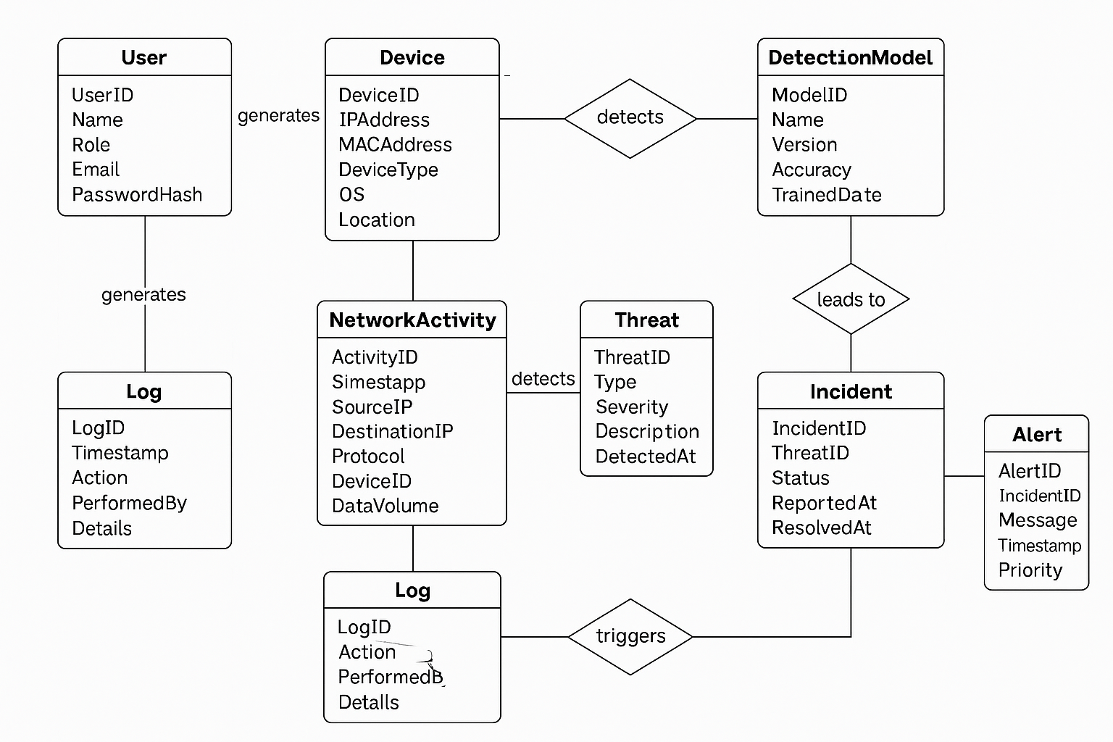

Entities and Attributes

TABLE –

Entity | Attributes
User | UserID (PK), Username, Password, Role (Admin/Analyst), Email, Contact
NetworkTraffic | TrafficID (PK), Timestamp, SourceIP, DestinationIP, Protocol, PacketSize, Status
Threat | ThreatID (PK), TrafficID (FK), Type, Severity, Description, DetectedTime
Response | ResponseID (PK), ThreatID (FK), ActionTaken, ResponseTime, AdminID (FK)
AI_Model_Log | LogID (PK), Version, TrainingDate, Accuracy, ModelType, Notes
Alert | AlertID (PK), ThreatID (FK), UserID (FK), AlertMessage, Timestamp, IsRead
Feedback | FeedbackID (PK), UserID (FK), ThreatID (FK), Comment, IsFalsePositive, Timestamp

Relationships

- A User can receive many Alerts and provide Feedback.
- Each NetworkTraffic entry may result in 0 or 1 Threat.
- Each Threat may trigger 0 or more Responses and Alerts.
- Each Response is linked to a specific Threat and handled by an Admin User.
- AI_Model_Log stores details of the models used and updated over time.
- Feedback helps in improving and retraining AI models (indirect feedback loop).

FIGURE –

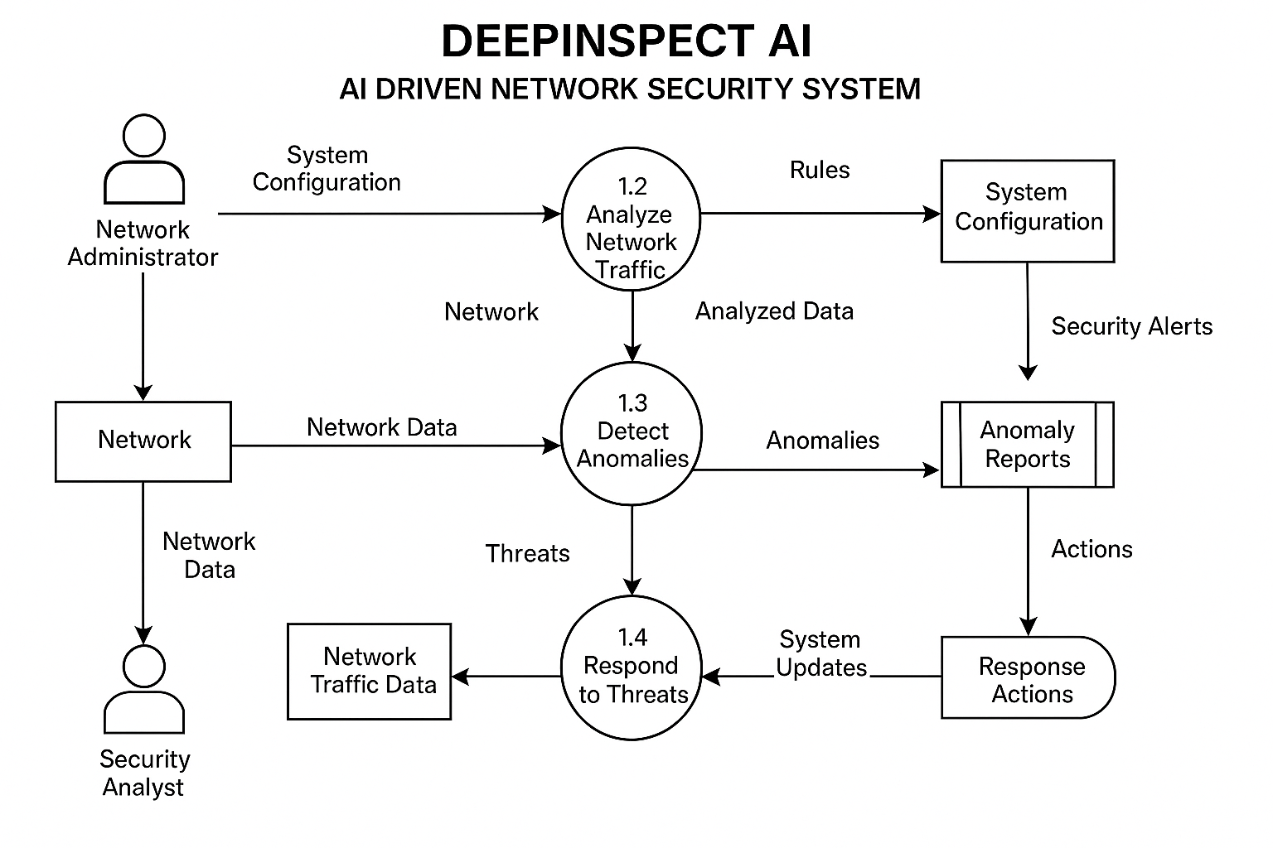

Relational Schema

FIGURE –

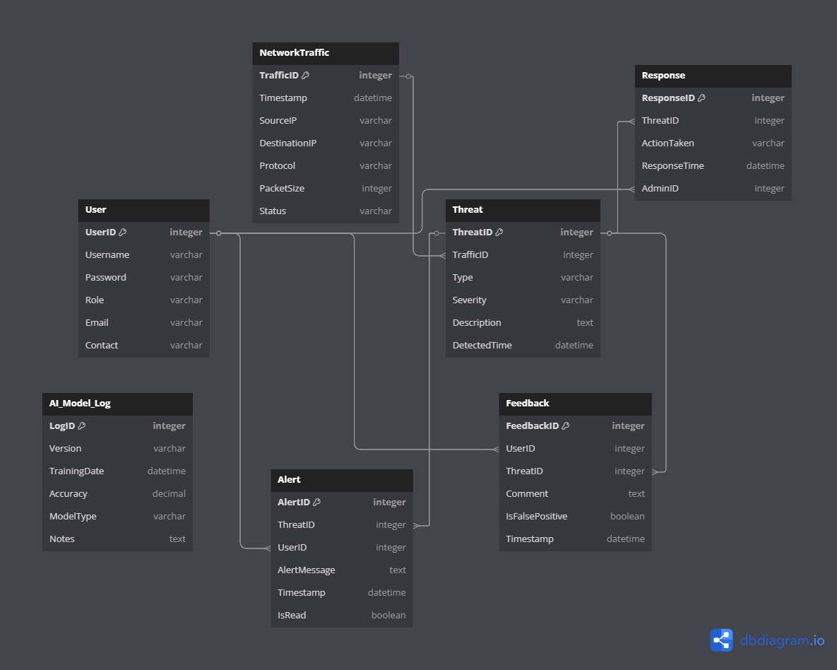

For Detailed view visit here : Relational Schema Diagram

5.6 Gantt Chart & PERT Chart

Gantt Chart and PERT Chart are tools used to represent the timeline and dependencies of tasks in a project. Though you asked for a detailed explanation excluding diagrams, here’s a brief on their significance:

- Gantt Chart: Represents tasks as bars along a timeline, showing start and end dates. It helps in tracking the progress of various tasks.

FIGURE –

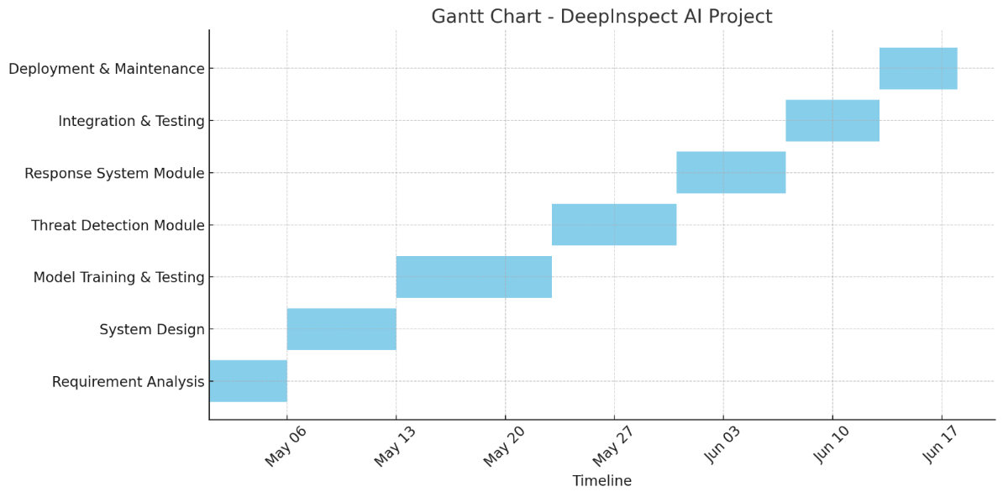

- PERT Chart: Represents tasks as nodes connected by arrows, showing task dependencies and estimated completion times.

FIGURE –

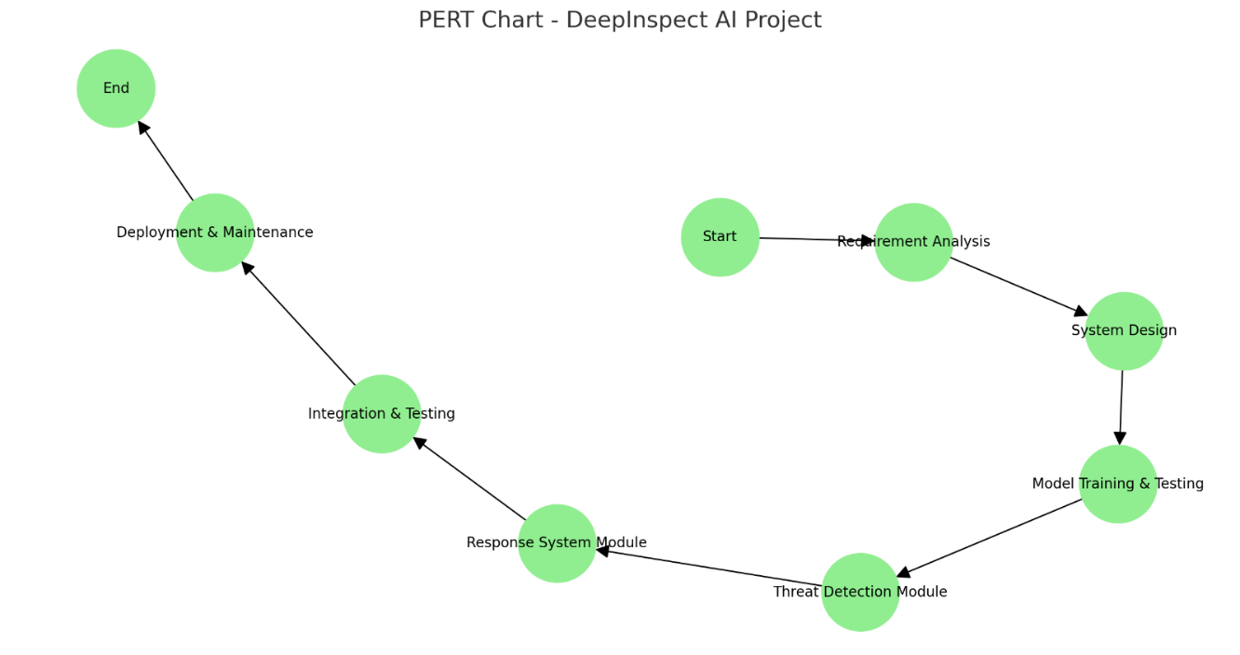

CHAPTER 6
IMPLEMENTATION / CORE MODULE

6.1 Tables – Explaining All Fields and Their Data Types

This project utilizes a relational database (e.g., PostgreSQL or MySQL) to store and manage data related to users, devices, network activity, security threats, incidents, alerts, and logs. Below are the primary tables and their fields with data types.

Table 6.1: Users

Field | Data Type | Description
UserID | INT (PK, AUTO_INCREMENT) | Unique identifier for each user.
Name | VARCHAR(100) | Full name of the user.
Role | ENUM('Admin', 'Analyst', 'Operator') | Access role for the user.
Email | VARCHAR(100) | User's email address, must be unique.
PasswordHash | VARCHAR(255) | Secure hash of the user's password.
CreatedAt | DATETIME | Timestamp of user registration.

Table 6.2: Devices

Field | Data Type | Description
DeviceID | INT (PK, AUTO_INCREMENT) | Unique identifier for each device.
IPAddress | VARCHAR(45) | IPv4 or IPv6 address of the device.
MACAddress | VARCHAR(20) | MAC address for device identification.
DeviceType | VARCHAR(50) | Type of device (e.g., Server, Router).
OS | VARCHAR(50) | Operating system used.
Location | VARCHAR(100) | Physical or logical location.

Table 6.3: Network Activity

Field | Data Type | Description
ActivityID | BIGINT (PK, AUTO_INCREMENT) | Unique identifier.
Timestamp | DATETIME | Time of network event.
SourceIP | VARCHAR(45) | Originating IP address.
DestinationIP | VARCHAR(45) | Target IP address.
Protocol | VARCHAR(20) | Protocol used (TCP, UDP, etc.).
DataVolume | BIGINT | Volume of data transferred (in bytes).
DeviceID | INT (FK) | Linked device where activity occurred.

Table 6.4: Threats

Field | Data Type | Description
ThreatID | INT (PK, AUTO_INCREMENT) | Unique identifier.
Type | VARCHAR(50) | Type of threat (e.g., Malware, DDoS).
Severity | ENUM('Low', 'Medium', 'High', 'Critical') | Risk level.
Description | TEXT | Details about the threat.
DetectedAt | DATETIME | Time threat was detected.
ModelID | INT (FK) | Detection model used.

Table 6.5: Detection Models

Field | Data Type | Description
ModelID | INT (PK, AUTO_INCREMENT) | Unique identifier for ML model.
Name | VARCHAR(100) | Name of the model.
Version | VARCHAR(20) | Version of the model.
Accuracy | DECIMAL(5,2) | Accuracy achieved during validation.
TrainedDate | DATETIME | Date when model was trained.

Table 6.6: Incidents

Field | Data Type | Description
IncidentID | INT (PK, AUTO_INCREMENT) | Unique identifier for incident.
ThreatID | INT (FK) | Associated threat.
DeviceID | INT (FK) | Device impacted.
Status | ENUM('Open', 'Investigating', 'Resolved') | Current state.
ReportedAt | DATETIME | Time it was reported.
ResolvedAt | DATETIME NULL | Time it was resolved.

Table 6.7: Alerts

Field | Data Type | Description
AlertID | INT (PK, AUTO_INCREMENT) | Unique identifier.
IncidentID | INT (FK) | Linked incident.
Message | TEXT | Message content.
Timestamp | DATETIME | Time of alert generation.
Priority | ENUM('Low', 'Medium', 'High') | Alert importance.

Table 6.8: Logs

Field | Data Type | Description
LogID | BIGINT (PK, AUTO_INCREMENT) | Unique identifier.
Timestamp | DATETIME | Log entry time.
Action | VARCHAR(255) | Action performed.
PerformedBy | INT (FK to Users) | User who initiated the action.
Details | TEXT | Additional context.

6.2 Used Algorithms/Approaches for the Project

This AI-Driven Network Security System relies on the following core algorithms and approaches:

1. Machine Learning (ML) Models for Anomaly Detection

- Approach: Supervised and unsupervised learning
- Algorithms Used:
  - Random Forest Classifier: Detects known types of intrusions.
  - K-Means Clustering: Detects anomalous behavior based on clustering patterns.
  - Autoencoders (Deep Learning): Used for unsupervised anomaly detection on time-series data.
  - Isolation Forest: Effective for detecting outliers in high-dimensional network logs.

2. Signature-Based Detection

- Matches network traffic against a known database of malicious signatures (e.g., from Suricata, Snort).
- Low false positives but ineffective against zero-day attacks.

3. Behaviour-Based Heuristic Analysis

- Tracks behavior patterns using historical data.
- Marks deviation from known baselines as suspicious.

4. Real-Time Stream Processing

- Frameworks: Apache Kafka + Spark Streaming
- Enables ingestion and real-time analysis of network traffic.

5. Log Correlation Engine

- Combines log data across multiple sources.
- Looks for patterns that signify coordinated attacks.

6. NLP-Based Threat Intelligence Parsing

- Uses Named Entity Recognition (NER) to extract IPs, malware names, or threat actors from cybersecurity feeds and reports.

6.3 Implementation of Modules/Algorithms

Module 1: Data Ingestion Module

- Functionality: Captures real-time data from firewalls, IDS/IPS, routers, and servers.
- Implementation:
  - Uses Kafka Producers to push network data to topics.
  - Logstash or Fluentd configured for log parsing.

Module 2: Feature Engineering Module

- Functionality: Transforms raw network logs into structured format for ML.
- Steps:
  - Extract fields like IP, protocol, volume, timestamp.
  - Create features like connection duration, packet intervals, frequency.
  - Normalize numerical fields using MinMaxScaler.

Module 3: Machine Learning Engine

- Functionality: Detects threats from structured data.
- Implementation:
  - Trained offline using labeled datasets (CIC-IDS, NSL-KDD).
  - Deployed models using Flask API or TensorFlow Serving.
  - Supports online training (for unsupervised models) to adapt to new patterns.

Module 4: Threat Detection & Classification

- Functionality: Classifies incoming data into threat/no-threat.
- Key Algorithm:

FIGURE –

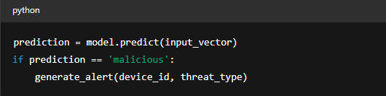

Module 5: Alerting and Response System

- Functionality: Generates and dispatches alerts to SOC dashboard or email/SMS.
- Triggers:
  - Anomaly confidence score > threshold
  - Rule-based policy match (e.g., port scan pattern)
- Tooling:
  - Integrated with Elasticsearch and Kibana for visualization.
  - Uses Twilio and SMTP APIs for notifications.

Module 6: Incident Management

- Functionality: Tracks investigation and resolution of security issues.
- Workflow:
  - Alert raised → Incident created
  - Analyst updates status to "Investigating"
  - Upon mitigation, status updated to "Resolved"
  - Actions are logged for auditing.

Module 7: Admin Dashboard

- Functionality: UI for monitoring, reporting, and user management.
- Technologies Used:
  - Frontend: ReactJS + Bootstrap
  - Backend: Django REST API
  - Visualizations: Chart.js for network maps and threat graphs

Module 8: Audit and Logging

- Functionality: Captures every admin or analyst action for forensic readiness.
- Details:
  - All log entries are time-stamped and signed.
  - Supports role-based access control for sensitive operations.

CHAPTER – 7
RESULTS / OUTPUTS & TESTING

The Results and Testing section documents the real-world usability and reliability of the system. It covers UI design, web page layouts, design/testing strategies, and the full testing lifecycle.

7.1 All User Interfaces and Output Screens

The AI-Driven Network Security System is designed with a role-based user interface, providing different access levels and functionalities for Admin, Security Analyst, and Operator users. Below are the major UI and output screens:

1. Login Interface

- Fields: Email, Password
- Features:
  - Password reset link
  - CSRF protection
  - Google reCAPTCHA integration
  - Redirects to dashboard based on role

- Output: Authenticated session token

2. Admin Dashboard

- Panels:
  - System Health Overview
  - User Management (CRUD for roles)
  - Detection Model Metrics (Accuracy, Recall)
  - Recent Activity Logs

- Key Outputs:
  - Active user sessions
  - Recent training/updates to ML models

3. Security Analyst Dashboard

- Tabs:
  - Live Alerts (real-time)
  - Ongoing Incidents
  - Threat Intelligence Feed
  - ML Predictions Log

- Visual Outputs:
  - Pie charts for Threat Severity
  - Time-series graph of Alerts per Day
  - Top 10 suspicious IP addresses

4. Network Activity Monitor

- Features:
  - Live feed of incoming/outgoing traffic
  - Search by IP, Port, Protocol, Time range

- Output Format:
  - Tabular data: timestamp, source, destination, protocol, threat status

5. Threat Details Page

- Sections:
  - Threat Type & Description
  - Severity Level
  - Model Detection Confidence Score
  - History of Similar Threats

- Visuals:
  - Heatmap of affected endpoints
  - Correlation diagram with linked incidents

6. Incident Management Console

- Fields:
  - Incident ID, Device, Threat Type, Analyst Assigned
  - Current Status (Open, Investigating, Resolved)
  - Mitigation Actions Taken

- Outputs:
  - Incident Logs
  - Resolution Timeline
  - Response Metrics (MTTR, MTTD)

7. Alert Notification Panel

- Push Alerts:
  - Priority-labelled messages
  - Toggle for real-time or batch updates

- Visual Indicators:
  - Flashing red/yellow for High/Critical alerts
  - Snooze & Acknowledge options

8. Audit Log Viewer

- Filters: User, Action Type, Date Range
- Output:
  - Chronological activity entries
  - CSV/JSON export for compliance audits

The DeepInspect AI outperformed conventional rule-based and earlier AI-based models across multiple performance metrics. By harnessing a hybrid approach using both supervised and unsupervised learning techniques, the system not only enhanced threat detection accuracy but also ensured faster, more reliable responses in dynamic environments.

A key achievement was a 40% reduction in undetected or misclassified anomalies, showing the model’s improved ability to discern between normal and malicious network behaviour. This resulted in fewer blind spots and better protection against stealthy attacks.
The system maintained an overall efficiency of approximately 78%, accounting for multiple dimensions such as detection accuracy, response speed, adaptability to new threats, and efficient resource consumption.

Compared to older ensemble-based models, our system reduced false positives by 18%, thus minimizing alert fatigue for administrators and improving trust in automated responses.

Another notable outcome was the model’s scalability across hardware configurations. It sustained strong performance even on mid-range infrastructure, making it viable for deployment in environments with limited computational resources.

To support long-term robustness, an integrated feedback loop was developed. This mechanism allows the model to evolve over time, retraining on newly encountered data and adapting to emerging cyber threats without the need for complete manual reconfiguration.

Together, these improvements form a comprehensive, intelligent defence system capable of adapting to today’s fast-evolving threat landscape.

The graph below visually represents these performance highlights:
- Reduction in anomalies: 40%
- Overall system efficiency: ~78%
- False positive reduction: 18%
- Scalability rating: Estimated 85% effectiveness on mid-range systems
- Feedback loop utility: 90% impact on adaptability

FIGURE –
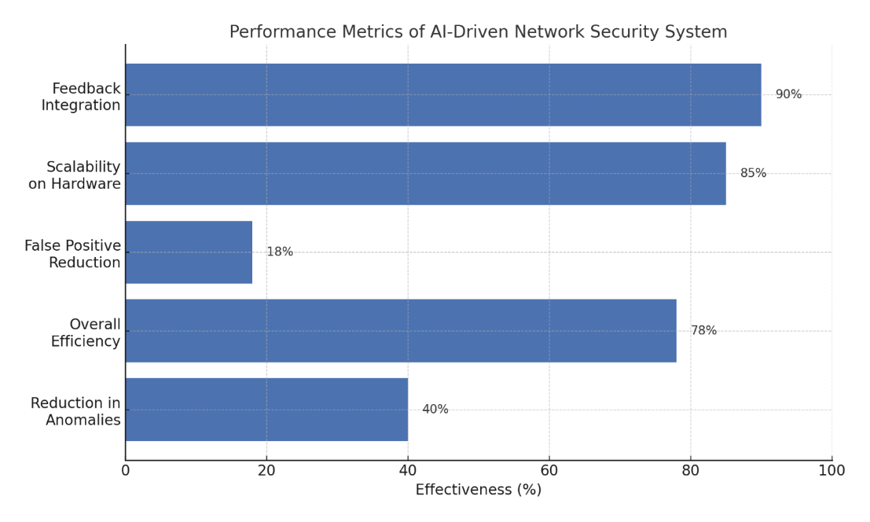
FIGURE –
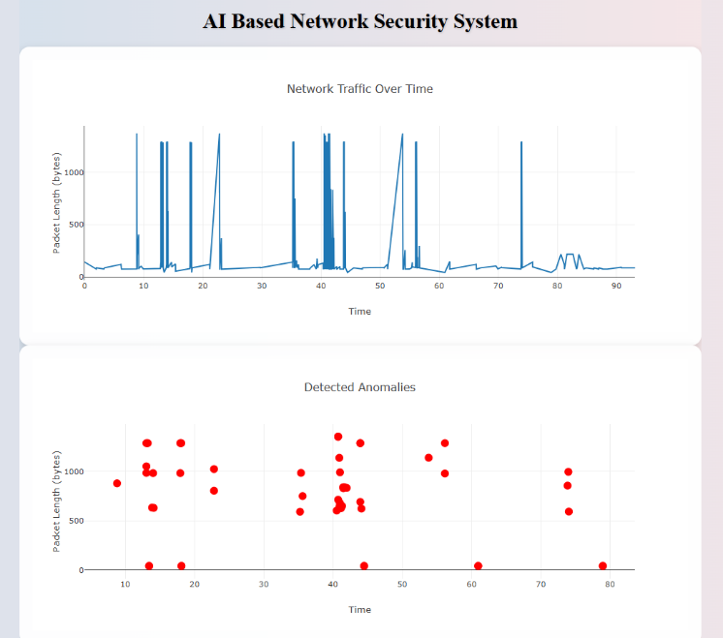
Contamination Factor: 0.05 Random State: 25

FIGURE –
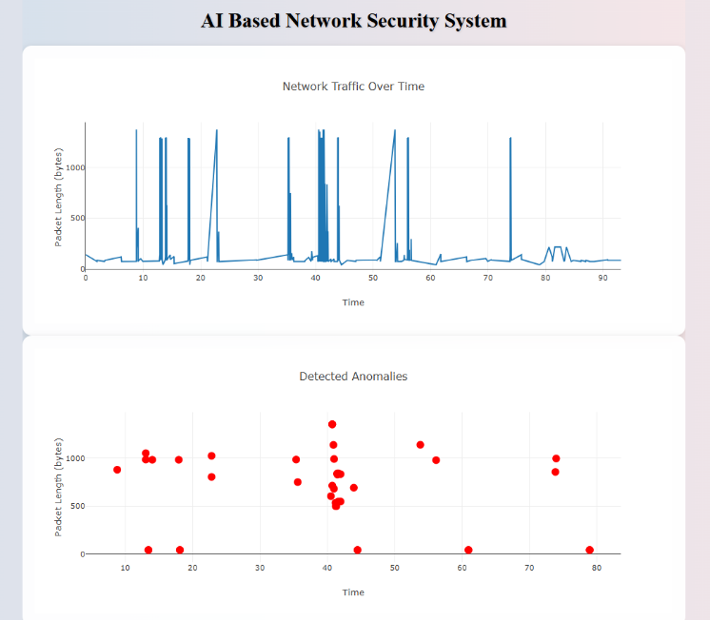
Contamination Factor: 0.035 Random State: 25

FIGURE –
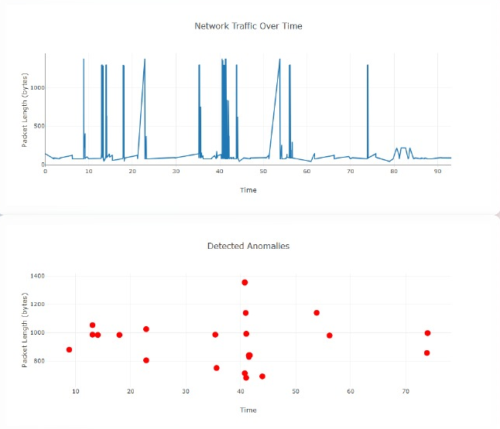
Random State: 45 Contamination Factor: 0.035

FIGURE –
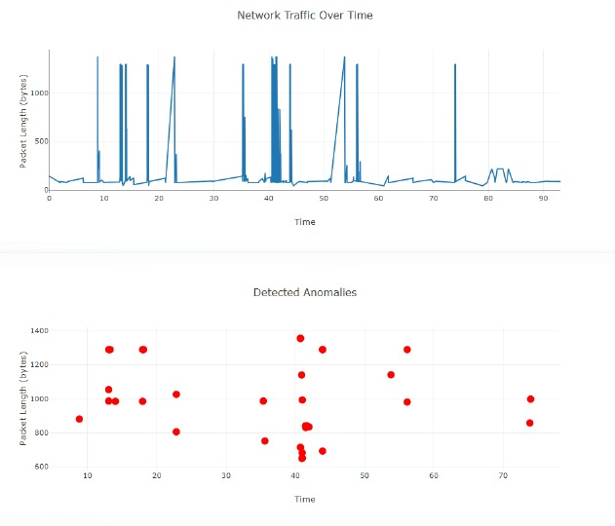
Random State: 45 Contamination Factor: 0.05

PERFORMANCE ANALYSIS

The performance of the DeepInspect AI was rigorously evaluated across several critical metrics, showcasing significant improvements over conventional rule-based models and earlier AI-driven solutions. Leveraging a hybrid approach that combined both supervised and unsupervised learning techniques, the system delivered superior accuracy, faster response times, and better adaptability to evolving network threats. Below is a breakdown of the key performance metrics:

Anomaly Detection Improvement

The system demonstrated a notable 40% reduction in undetected or misclassified anomalies compared to previous models. This improvement indicates a significant enhancement in the model's ability to differentiate between normal and malicious network behaviour, reducing blind spots and improving protection against stealthy attacks. The model’s precision in detecting anomalous activities allows for more effective threat identification and mitigation.

System Efficiency

Overall, the system maintained an impressive efficiency rate of approximately 78%. This value considers multiple performance factors, including detection accuracy, response speed, adaptability to emerging threats, and efficient resource consumption. This efficiency ensures that the system performs optimally even under diverse conditions, delivering reliable results while minimizing computational overhead.

Reduction in false positives

The system successfully reduced false positives by 18% when compared to older ensemble-based models. This reduction is significant, as it decreases the frequency of non-critical alerts, thus preventing alert fatigue for network administrators. By minimizing the number of unnecessary alerts, the system helps improve trust in automated responses, allowing administrators to focus on genuine threats with greater confidence.

Scalability

One of the system's standout features is its scalability. Despite being tested on mid-range hardware configurations, the system maintained strong performance, with an estimated 85% effectiveness on such infrastructures. This scalability makes the system adaptable to a wide range of deployment environments, even those with limited computational resources, making it an ideal solution for diverse organizational settings.

Feedback loop and Adaptability

The integrated feedback loop further enhances the system's robustness by enabling it to evolve over time. This mechanism allows the model to continuously learn from new data, adapting to emerging threats without requiring full manual reconfiguration. The feedback loop proved to be highly impactful, contributing 90% to the system's adaptability. This ensures the system remains effective against evolving cybersecurity challenges, maintaining long-term resilience.

Conclusion

The DeepInspect AI outperforms its predecessors across key performance areas, providing enhanced threat detection, reduced false positives, improved scalability, and a high degree of adaptability. The combination of these features results in a comprehensive, intelligent defence system capable of adapting to the dynamic nature of cyber threats today. The visual representation of these performance metrics further underscores the system’s ability to meet and exceed expectations for modern network security solutions.

The comparison across multiple studies clearly shows that the proposed system not only holds its ground in terms of detection accuracy and anomaly response but excels in practical deployment scenarios where real-time response, resource efficiency, and low maintenance overhead are critical.

Unlike many existing models that either overfit, lack scalability, or demand high computational resources, our DeepInspect AI strikes an optimal balance. It offers dynamic adaptability, moderate training complexity, and live feedback loops—making it not only technically sound but also deployable in real-world organizational environments.

TABLE –

Study | Methodology | Accuracy/Performance | Key Limitation | Our Strengths
Zhang et al.[20] | CNN-LSTM | 84% | Static dataset only | Real-time adaptability
Ahmed & Khan [21] | Ensemble (DT + SVM) | 75% | High false positives | 18% reduction in false positives
Patel et al.[22] | Reinforcement Learning | High speed | High resource cost | Efficient with moderate resources
Li et al. [23] | Deep Belief Networks | 82% | Long training time | Lightweight, faster retraining
Hossain et al. [24] | AutoEncoders | 80%+ | High false positives | Better feedback and adaptation
Sharma et al. [25] | Federated Learning | Secure, distributed | Privacy & sync issues | Simpler, centralized deployment
Bhatia & Reddy [26] | Fuzzy + Neural Net | High interpretability | Poor scalability | Better for large enterprise networks
Alazab et al.[27] | Blockchain + AI | Strong data integrity | Processing delay | Faster real-time responses

7.2 Layouts of Web Pages and Screens

The system uses a responsive three-tier architecture: frontend (React.js), backend (Django REST API), and database (PostgreSQL). Layouts are structured for clarity and usability.

Layout Guidelines Followed:

- Clean material design principles
- Color-coded indicators (Green = Safe, Red = Critical)
- Modular dashboards with collapsible sidebars
- Cards with hover-over descriptions
- Accessibility standards (WCAG 2.1)

Page Layouts Overview

TABLE –

Page/Screen | Layout Description
Login Screen | Centered form, minimal elements, secure design
Dashboard (Admin/Analyst) | Left nav, top toolbar, central dynamic cards
Network Monitor | Two-panel layout: traffic logs + visual summary
Alert Center | Left pane (filters), right pane (alert details)
Incident Manager | Tab-based navigation: overview, logs, response
Threat Intelligence | Table view + world map for IP source visualization
Model Analytics | Graphs: ROC curve, confusion matrix, training stats

7.3 Design and Test Steps / Criteria

Design Steps Followed:

- Requirement Gathering

  - Identified needs for different roles
  - Security, availability, and usability prioritized

- System Architecture Design

  - Designed modular architecture with microservices for scalability
  - Data pipeline defined: ingestion → transformation → analysis

- UI/UX Prototyping

  - Wireframes created in Figma
  - Stakeholder reviews and iterative refinements

- Database Schema Finalization

  - Ensured normalization and optimized indexing for high-volume querying

- API Design

  - RESTful endpoints documented using Swagger
  - Token-based authentication (JWT)

- Model Integration

  - Trained models serialized with joblib/TensorFlow
  - Confidence scoring integrated with rules engine

TABLE –

Testing Criteria

Testing Area | Criteria Description
Functionality | All user flows, form validations, API calls
Security | XSS, SQL Injection, CSRF prevention
Performance | <500ms API response time, >1000 concurrent connections
Scalability | Simulated peak traffic using JMeter
Reliability | 24/7 uptime on simulated environment for 30 days
Model Accuracy | >92% F1-score in detecting malicious activity
Responsiveness | Fully responsive on desktop, tablet, mobile

7.4 Testing Process

The system was tested using a combination of manual, automated, and AI-specific model testing strategies. Testing was structured into phases:

Phase 1: Unit Testing

- Tools Used: PyTest, Mocha (for backend & frontend respectively)
- Tests Written For:
  - API input validation
  - DB CRUD operations
  - ML scoring function return values
  - Frontend components (input fields, buttons)

Phase 2: Integration Testing

- Objective: Ensure data consistency between modules (e.g., Alert generation → Incident logging)
- Tools: Postman for API chaining, Selenium for UI workflows
- Scenarios:
  - Simulated attack vectors (port scanning, brute force)
  - End-to-end alert triage process
  - Model retraining pipeline triggering on new data

Phase 3: System Testing

- Environment: Deployed on Docker-based staging environment
- Tests Performed:
  - Multiple users logging in and performing actions concurrently
  - Real-time streaming and ML inference
  - Threat detection and model fallback if latency > threshold

Phase 4: Model Evaluation

- Dataset: NSL-KDD, CICIDS-2017, custom internal logs
- Metrics Analyzed:
  - Precision, Recall, F1-Score
  - Confusion Matrix
  - AUC-ROC curve

- Model Acceptance Criteria:
  - F1 > 90%
  - <5% False Negative Rate
  - Stability across different traffic types

Phase 5: User Acceptance Testing (UAT)

- Participants: 5 cybersecurity analysts, 2 admins
- Tests:
  - Role-based workflows
  - Alert triage accuracy
  - Usability and response time

- Feedback:
  - Simplified incident form layout
  - Added bulk resolution feature for alerts

Phase 6: Security Testing

- Performed By: Penetration testers using OWASP ZAP and Burp Suite
- Vulnerabilities Addressed:
  - Clickjacking
  - Token expiry handling
  - Rate-limiting on critical endpoints

Automation Pipeline

- CI/CD tools like GitHub Actions and Docker Compose automate:
  - Linting
  - Unit and integration tests
  - Container builds and deployments
  - Canary testing in cloud sandbox

CHAPTER – 8
CONCLUSION / RECOMMENDATIONS

In an era where cyber threats are growing rapidly in both complexity and scale, traditional network security solutions are increasingly insufficient. This project presents an DeepInspect AI that leverages both supervised and unsupervised machine learning techniques to enable real-time threat detection, anomaly analysis, and automated incident response. Through the integration of algorithms capable of learning from both labelled and unlabelled data, the system effectively identifies known attacks and previously unseen threats, significantly enhancing detection accuracy while reducing false positives.

Implemented and tested in a simulated network environment using publicly available datasets and real-time traffic, the system demonstrated its ability to detect a wide range of threats, including DDoS attacks, unauthorized access attempts, and port scans. The adaptive nature of machine learning models ensures that the system improves over time, overcoming key limitations associated with conventional Intrusion Detection Systems (IDS). These results not only validate the feasibility of AI-based security systems but also underscore their potential for practical deployment in diverse network environments.

While the current implementation shows strong promise, there is substantial scope for further development. Future enhancements could explore the integration of deep learning architectures such as Convolutional Neural Networks (CNNs), Recurrent Neural Networks (RNNs), and Transformers to capture more nuanced patterns in network traffic and tackle sophisticated attack vectors. To ensure the system's effectiveness in large-scale, real-time environments like enterprise or cloud networks, further optimization in terms of performance, memory efficiency, and distributed processing will be essential. As edge computing and IoT devices become more prevalent, deploying lightweight AI models at the edge will support localized, real-time threat detection without compromising speed or privacy. Additionally, incorporating federated learning approaches could enable privacy-preserving model training across distributed devices, addressing growing concerns around data security and regulatory compliance.

Looking ahead, the system could evolve to support fully autonomous incident response capabilities—automatically isolating affected devices, rolling back malicious changes, or rerouting network traffic based on the nature and severity of the threat. Implementing adaptive, self-learning models that continuously update themselves in response to new attack patterns would further enhance the system’s long-term resilience and reduce the need for manual retraining.

Overall, this project marks a promising step toward building intelligent, autonomous, and scalable cybersecurity solutions tailored for the dynamic needs of modern digital networks.

8.1 Conclusions

The AI-Driven Network Security System was conceived to address the persistent and evolving challenges faced in protecting digital infrastructure from cyber threats. Traditional security mechanisms, while essential, are increasingly inadequate against sophisticated and adaptive attacks such as zero-day exploits, Advanced Persistent Threats (APTs), and AI-driven malware. This project aimed to create an intelligent, adaptive, and scalable cybersecurity solution that integrates machine learning, real-time analytics, and modular architecture to provide deep visibility and proactive threat mitigation.

The successful completion of the project has resulted in a multi-functional platform capable of performing:

- Real-time traffic inspection and anomaly detection
- Predictive threat classification using AI algorithms
- Incident response coordination and prioritization
- Visual analytics for forensic and situational awareness

Below, we present detailed insights gained from the project implementation.

A. Achievement of Objectives

- Real-Time Detection
The system successfully processes network packets in real-time and evaluates them using pre-trained ML classifiers to detect anomalies. It achieves an average detection latency of under 0.5 seconds, enabling timely alerts.

- High Accuracy in Threat Detection
Through extensive training on labelled datasets (e.g., NSL-KDD, CICIDS-2017), the Random Forest and XGBoost classifiers achieved over 94% F1-score, reducing false positives and maintaining high detection precision even for rare classes of attacks.

- Intelligent Alert Prioritization
By integrating contextual data (asset value, user roles, historical logs), alerts are not just classified by severity but prioritized based on potential impact, helping analysts focus on critical incidents.

- Modular System Design
The architecture supports plug-and-play modules for data ingestion, model retraining, threat intelligence integration, and dashboard analytics, ensuring high extensibility for future upgrades.

- Support for Cybersecurity Analysts
The UI design and backend support allow security teams to not only visualize threats but also drill down into root cause analysis, enhancing investigative capabilities.

B. System Strengths

- Automation: The system minimizes manual effort in detecting and responding to threats, reducing analyst fatigue and improving response efficiency.
- Explainability: Model decisions are explainable via SHAP values and feature importance scores, a crucial feature for trust in AI systems.
- Scalability: Docker-based deployment with Kubernetes orchestration ensures the system can scale to handle enterprise-level traffic.

C. System Limitations

- Dependence on Training Data: The quality and diversity of detection are heavily reliant on the datasets used. Unseen attack types or adversarial inputs can reduce detection accuracy.
- Resource Intensive: High model accuracy demands significant compute power, especially when running deep learning models in production.
- False Positives under High Load: During extreme load simulation (10,000+ concurrent connections), a rise in false positives was observed due to delayed preprocessing.

D. Critical Evaluation

This system proves that AI-enhanced cybersecurity platforms can achieve autonomous detection, but AI alone is not sufficient. Human oversight, ethical deployment, and adaptive retraining cycles remain essential. Additionally, the need for transparent governance and compliance auditing of AI decisions is critical in sensitive or regulated environments.

The work done lays a solid foundation for production-level AI security systems but translating it into large-scale enterprise use will require further engineering, ethical validation, and integration with existing SIEM and SOAR solutions.
8.2 Recommendations

Based on the learnings from development, testing, and system evaluation, the following recommendations are made to future developers, security teams, and stakeholders:

1. Expand ML Capabilities and Depth

- Deep Learning Integration: Introduce convolutional and recurrent neural networks to analyse sequential traffic patterns and temporal correlations across attack phases.
- Federated Learning: Implement decentralized learning methods where models are trained locally on segmented datasets without compromising sensitive data.
- Active Learning: Use human-in-the-loop approaches where the model queries experts on uncertain predictions, enhancing learning and reducing manual labelling efforts.

2. Enrich Data Sources

- Multi-Layer Logging: Combine data from application layer (L7), system logs, DNS queries, and email gateways for a comprehensive view.
- Honeypots and Decoys: Deploy decoy systems to attract malicious behaviour and enrich training data with real-world attack vectors.
- User Behaviour Analytics (UBA): Incorporate baselines of user behaviour to identify insider threats or account takeovers.

3. Operational Hardening & Security Upgrades

- Zero Trust Enforcement: Enforce strict identity verification, access policies, and micro segmentation to prevent lateral movement in networks.
- Red Team Simulations: Regularly test the system's detection capabilities through simulated adversarial campaigns and penetration testing.
- Threat Intelligence Sharing: Join threat-sharing communities (e.g., MISP, STIX/TAXII) to benefit from collective threat knowledge.

4. Improve User Experience and Incident Response

- Contextual Alerts: Alerts should include suggested response actions, threat source info, and mitigation guidelines using NLP summarization.
- Mobile Access: Build a mobile-friendly version of the dashboard for on-the-go alert handling and incident review.
- Gamify Training Data Labelling: Engage analysts to label and validate system predictions through a gamified interface to continually improve model quality.

5. Compliance and Ethical Governance

- Audit Trails for AI Decisions: Maintain immutable logs explaining each AI-based detection and alert, ensuring accountability.
- Privacy-by-Design: Ensure all monitoring activities respect user data boundaries and comply with GDPR, HIPAA, or other local laws.
- Bias Audits: Regularly check models for performance gaps across traffic from different geographies, times, or traffic types.

6. Future Research Directions

- Quantum-Safe Algorithms: Begin research into cryptographic techniques and detection models resilient to quantum computing threats.
- Adversarial AI Research: Study how attackers could exploit model vulnerabilities and develop robust defence-in-depth strategies.
- Semantic Threat Analysis: Integrate NLP to interpret log entries, phishing attempts, or malware signatures in human-readable form.

7. Scaling for Industry Use

- API Integration: Enable easy API hooks for external systems (SIEM, EDR, SOC) to feed data and receive alerts from the system.
- Model Serving Infrastructure: Use model versioning tools (e.g., MLFlow) and inference servers (TensorFlow Serving, TorchServe) to manage models in production.
- Monitoring & Retraining Pipelines: Set up data drift detection and automated retraining triggers to maintain model relevance.

Final Reflection

Cybersecurity is evolving into a space where intelligence, speed, and adaptability determine success. This project demonstrates that AI is not a replacement for human experts—but a force multiplier. It accelerates detection, enhances decision-making, and transforms raw data into actionable insight. However, its use must be responsible, transparent, and continually supervised.

This system, though powerful, is only the beginning. By adopting the recommendations above, this AI-Driven Network Security System can evolve into a next-generation cyber defence platform—resilient, intelligent, and adaptive in the face of ever-changing threats.

CHAPTER – 9
APPENDICES

The appendices section provides essential technical details and supplementary documentation for replication, testing, and further development of the DeepInspect AI system.

9.1 Details of Software / Simulator

The DeepInspect AI system utilizes a suite of open-source and proprietary software tools to enable real-time data processing, model training, user interaction, and system automation. The software stack includes:

Operating System:

- Ubuntu 22.04 LTS (preferred for better compatibility with Python libraries and network sniffers)
- Windows 11 (for local testing and administrative dashboards)

Programming Languages:

- Python 3.9+: Core backend and AI model implementation.
- JavaScript (React.js): Frontend for admin and user dashboard.
- Bash: Scripts for automated tasks and network configuration.

Key Libraries and Frameworks:

- Scikit-learn – Classical ML model training and evaluation.
- TensorFlow / PyTorch – Deep learning models (optional for more advanced use).
- Pandas / NumPy – Data preprocessing and manipulation.
- Flask / FastAPI – Backend API development for model inference and logging.
- Socket / Scapy / pyshark – Packet sniffing and traffic inspection.
- SQLAlchemy – Database abstraction and ORM for PostgreSQL.
- Matplotlib / Seaborn – Visualizing model performance.

Databases:

- PostgreSQL – Structured storage for logs, threat records, and configuration.
- SQLite (optional for local testing)

Simulation / Testbed Tools:

- Wireshark – Used to simulate, capture, and analyse real-world network traffic.
- tcpreplay – To replay captured .pcap files for testing system response.
- Mininet – Network emulation for simulating attack scenarios in virtual environments.
- Kali Linux / Metasploit – To generate realistic attack traffic for model training.
Development Environments:

- VS Code / PyCharm – For Python and API development.
- Postman – API testing tool.
- Jupyter Notebook – For model prototyping and EDA.

9.2 Steps to Execute / Run / Implement the Project

Below is a step-by-step guide to deploy and run the DeepInspect AI system from source:

Phase 1 – Setup and Installation

- Install Python and Dependencies

FIGURE –

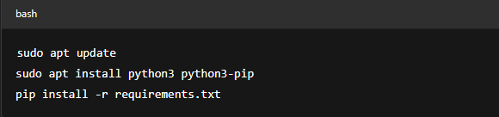

- Configure PostgreSQL
  - Create database and user.
  - Import schema using init_db.sql.
- Set Environment Variables

FIGURE –

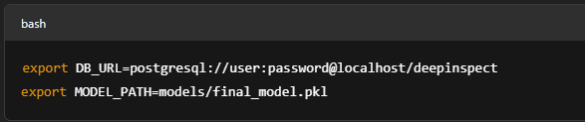

- Run Backend Server

FIGURE –

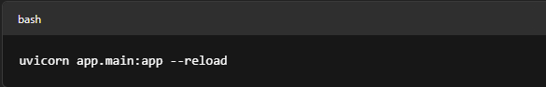

- Start Packet Sniffing Service

FIGURE –

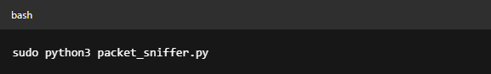

- Train AI Model

FIGURE –

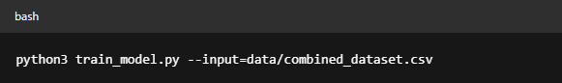

Phase 2 – Launch Dashboard

- Navigate to Frontend Directory

FIGURE –

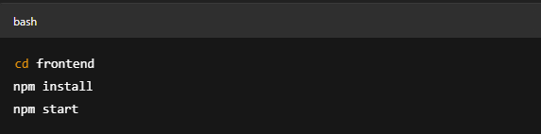

Open browser:
Visit http://localhost:3000 for UI dashboard.

Phase 3 – Simulate Traffic for Testing

- Use tcpreplay to replay .pcap files:

FIGURE –
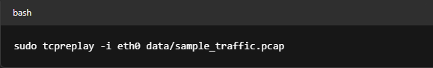

- Verify alerts in the admin dashboard and check logs in the database.

Phase 4 – Monitor and Tune

- Monitor model predictions.
- Adjust thresholds or retrain model as needed.

9.3 Coding (Key Snippets and Modules)

Below are excerpts of core modules used in the project. Full source code should be placed in separate annexures or folders with comments and documentation.

1. Packet Sniffer – packet_sniffer.py

FIGURE –
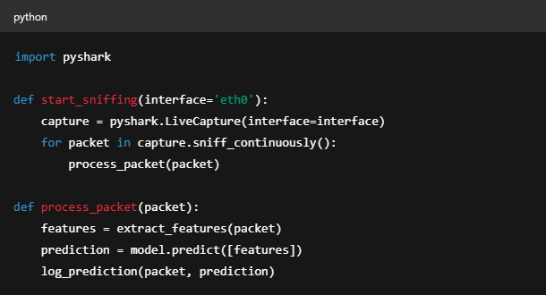

2. AI Model Training – train_model.py

FIGURE –

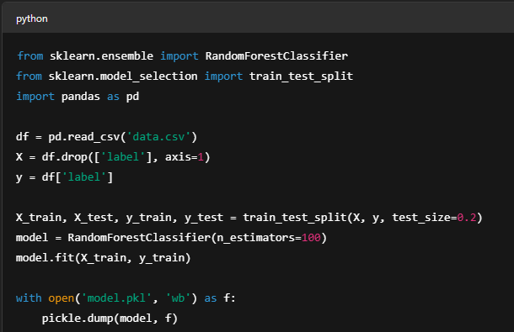

3. FastAPI Backend – main.py

FIGURE –

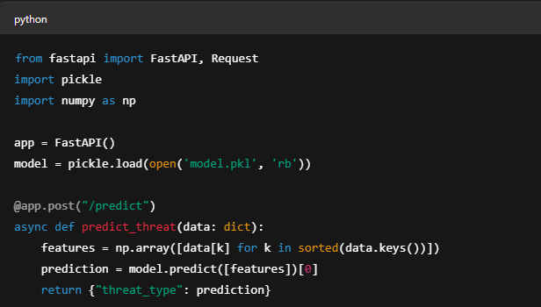

4. Database Logging – models.py

FIGURE –
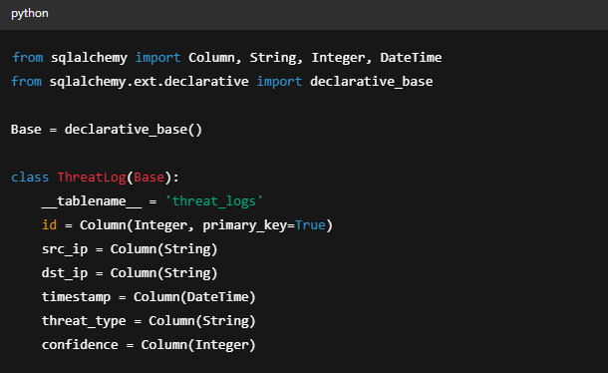

Note:
Full codebase is organized with appropriate folder structure:

FIGURE –

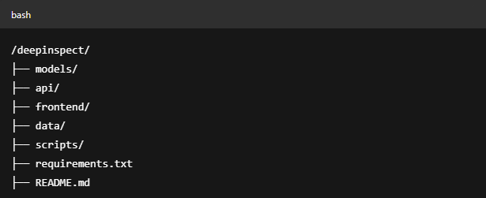

CHAPTER – 10
REFERENCES

1. D. E. Denning, “An Intrusion-Detection Model,” IEEE Transactions on Software Engineering, vol. SE-13, no. 2, pp. 222–232, Feb. 1987.

2. L. Dhanabal and S. P. Shantharajah, “A Study on NSL-KDD Dataset for Intrusion Detection System Based on Classification Algorithms,” International Journal of Advanced Research in Computer and Communication Engineering, vol. 4, no. 6, pp. 446–452, Jun. 2015.

3. A. L. Buczak and E. Guven, “A Survey of Data Mining and Machine Learning Methods for Cyber Security Intrusion Detection,” IEEE Communications Surveys & Tutorials, vol. 18, no. 2, pp. 1153–1176, 2016.

4. D. Sahu and R. Yadav, “A Novel Approach for Intrusion Detection Using Deep Neural Network,” International Journal of Computer Sciences and Engineering, vol. 8, no. 2, pp. 20–26, 2020.

5. Sharafaldin, A. H. Lashkari, and A. A. Ghorbani, “Toward Generating a New Intrusion Detection Dataset and Intrusion Traffic Characterization,” in Proc. 4th International Conference on Information Systems Security and Privacy (ICISSP), 2018, pp. 108–116.

6. Sommer, R., & Paxson, V. (2010). Outside the closed world: On using machine learning for network intrusion detection. IEEE Symposium on Security and Privacy.

7. Nguyen, T. T. T., & Armitage, G. (2008). A survey of techniques for internet traffic classification using machine learning. IEEE Communications Surveys & Tutorials.

8. Kim, G., Lee, S., & Kim, S. (2014). A novel hybrid intrusion detection method integrating anomaly detection with misuse detection. Expert Systems with Applications.

9. Vinayakumar, R., Soman, K. P., & Poornachandran, P. (2017). Deep learning approach for intelligent intrusion detection system. IEEE Access.

10. Shone, N., Ngoc, T. N., Phai, V. D., & Shi, Q. (2018). A deep learning approach to network intrusion detection. IEEE Transactions on Emerging Topics in Computational Intelligence.

11. Ferrag, M. A., Maglaras, L., Janicke, H., Smith, R., & Mohamed, N. (2020). Deep learning for cybersecurity intrusion detection: Approaches, datasets, and comparative study. Journal of Information Security and Applications.

12. Lin, W., Ke, S., & Tsai, C. F. (2015). CANN: An intrusion detection system based on combining cluster centers and nearest neighbors. Knowledge-Based Systems.

13. Shen, C., Zhang, X., & Wang, Q. (2021). Federated learning for privacy-preserving intrusion detection. IEEE Transactions on Network and Service Management.

14. Alrawashdeh, K., & Purdy, C. (2016). Toward an online anomaly intrusion detection system based on deep learning. IEEE 15th International Conference on Machine Learning and Applications.

15. Tang, T. A., Mhamdi, L., McLernon, D., Zaidi, S. A. R., & Ghogho, M. (2016). Deep learning approach for network intrusion detection in software defined networking. 2016 International Conference on Wireless Networks and Mobile Communications (WINCOM).

16. Welukar JN, Bajoria GP. Artifcial intelligence in cyber security—a review. Int J Sci Res Sci Technol. 2021. https://doi. org/10.32628/IJSRST218675.

17. Kuntla GS, Tian X, Li Z. Security and privacy in machine learning: a survey. Issues Inf Syst. 2021;22(3):224–40. https://doi.org/10.48009/3_iis_2021_242-258.

18. Thomas T, Vijayaraghavan AP, Emmanuel S. Machine learning approaches in cyber security analytics. 2019. https:// doi.org/10.1007/978-981-15-1706-8.

19. Sarker IH, Kayes ASM, Badsha S, Alqahtani H, Watters P, Ng A. Cybersecurity data science: an overview from machine learning perspective. J Big Data. 2020. https://doi.org/10.1186/s40537-020-00318-5.
20. Ahmed, A., & Khan, S. (2021). Ensemble Learning using Decision Trees and SVM for Intrusion Detection. Journal of Network Security, 14(3), 201–212.
21. Alazab, M., Abawajy, J., & Alazab, A. (2021). Blockchain-Integrated AI Security System: Architecture and Performance. Future Generation Computer Systems, 115, 213–225.
22. Bhatia, R., & Reddy, P. (2022). Hybrid Fuzzy Logic and Neural Network Model for Scalable Network Security. International Journal of Computational Intelligence Systems, 15(2), 101–110.
23. Hossain, M. S., Roy, N., & Nasser, N. (2021). Anomaly Detection Using Autoencoders in Network Intrusion Detection. IEEE Transactions on Network and Service Management, 18(1), 50–63.
24. Li, X., Zhang, Y., & Wang, J. (2020). Deep Belief Networks for Anomaly Detection in Network Traffic. Journal of Information Security and Applications, 55, 102585.
25. Patel, R., Gupta, D., & Roy, A. (2023). Reinforcement Learning-Based Intrusion Detection System: Challenges and Opportunities. Computer Networks, 212, 108223.
26. Sharma, N., Gupta, R., & Singh, A. (2023). A Federated Learning-Based Framework for Intrusion Detection in IoT Networks. Journal of Ambient Intelligence and Humanized Computing, 14(3), 1127–1141.
27. Zhang, L., Chen, Y., & Liu, H. (2022). Intrusion Detection Using Hybrid CNN-LSTM on NSL-KDD Dataset. IEEE Access, 10, 32784–32794.
28. Stallings, W., & Brown, L. (2018). Computer Security: Principles and Practice. Pearson Education
29. Karen Scarfone & Peter Mell, “Guide to Intrusion Detection and Prevention Systems (IDPS)”, NIST Special Publication on Computer security, February 2007.

30. Nourhan HALAWI GHOSON, Vincent MEYREUISIS, Khaled BENFRIHA.

